**Spatial Modelling of Road Traffic Accidents in Oyo State, Nigeria**

**1KORTER, G.O., 2O.E., OLUBUSOYE & 3A.A. SALISU**

1Department of Statistics, University of Ibadan. [kortergrace@gmail.com](mailto:kortergrace@gmail.com)

2Department of Statistics, University of Ibadan. [busoye2001@yahoo.com](mailto:busoye2001@yahoo.com)

3Department of Economics, University of Ibadan. [adebare1@yahoo.com](mailto:adebare1@yahoo.com)

**Abstract**

Roads often become sources of sorrow and venues of loss. Road accidents are a global scourge characteristic of our technological era, whose list of victims insidiously grows longer day by day. Most families have found themselves mourning, surrounded by indifference that is all too common as if this was a price that the society has to pay for the right to travel. The basic underlying assumption is that there is a spill over effect across the study area. The neighbourhood characteristics focused on the queen and rook contiguity based on weight matrices. The paper investigated the possible exogenous variables and built a spatial model for predicting areas with higher than expected future likelihood of accidents while controlling for spatial dependence. Removing the effect of spatial lag variable from the dependent variable (number of accidents), the area of each Local Government Authority, residential population, major road lengths and travel densities were used to predict areas with higher than expected future likelihood of accidents. The sign of the coefficient for the area is positive. This means an increase in the area of administration of local government authorities will lead to more accidents in each local government area. All other things being equal, Local Governments Areas with larger residential populations tend to have more accidents. The existence of a freeway link crossing a local government area reduces, on average approximately one accident for the period under study.

Travel densities are negatively related to number of accidents, which suggests inhibiting factors in the sense that traffic generated tend to be associated with fewer crashes.

**Keywords**: Road traffic accidents, spill over effect, spatial lag modelling, maximum likelihood estimation

**Introduction**

Road accidents are a global scourge characteristic of our technological era, whose list of victims insidiously grows longer day by day. Most families have found themselves mourning, surrounded by indifference that is all too common as if this was a price that the society has to pay for the right to travel. The frequencies of deaths, injuries, environmental degradation, material losses and the economic impact of this seemingly unpreventable phenomenon is a global issue of concern WHO (2004).

The growing menace of motor crashes in Nigeria caused by the unsafe state of road traffic environment renders every road user vulnerable to untimely death. A distribution of point locations, such as, with automobile crashes suggests a density distribution. Crashes occurring spatially close together are the products of higher levels of traffic, which in turn are a function of more concentrated social activities, either residential, employment or employment- related such as shopping and entertainment Levine et al. (1995a).

The occurrence of accidents at a geographical location affects similar occurrence at neighbouring locations across space. The extent of this spillover effect, the spatial dependence, affects the frequency of the event which leads to high or low concentration. When the spatial dependence is high, what obtains in a spatial unit is strongly related to what obtains across spatial units that are clustered Moran (1948) and Getis and Ord (1992).

Thus, to observe a significant remedial effect, the spatial pattern must be determined. For instance, safety and security measures will best be implemented across spatial units with the same level of concentration. The significance of trip generators, namely, exogenous variables that indirectly generate accidents also needs to be determined before policies on safety and security are made. Policy issues and decision making will be better guided with the knowledge of the ‘victims’ pains, hotspots, the measure of spatial dependence and higher than expected future likelihood of accidents’ locations.

The basic underlying assumption is that there is a spill over effect across the study area. The neighbourhood characteristics will focus on the queen and rook contiguity based weight matrices. The objective of this paper is to identify possible exogenous variables and build a spatial model that will predict areas with higher than expected future likelihood of accidents while controlling for spatial dependence.

This study is organized as follow: Introduction, Literature Review, Materials and Methods, Results and Discussion, Conclusion and Recommendations.

The pinpoint concentrations of the road traffic crashes’ data reveal a cross – sectional spatial pattern. The existence of a spatial interaction between contiguous road traffic crashes’ pinpoint locations reveal spatial concentrations and hence suggests spatial dependence between individual road traffic crashes’ occurrences. Thus, the issue of space and spatial dependence are inevitable. Spatial dependence in a collection of sample data implies that observations at location  depend on other observations at locations**.** Formally**,,  .** Note that the dependence can be among several observations, as the index can take on any value from**.**

Road casualties are random events and each single event is unpredictable in the very strong sense. Yet, the number of accidents recorded within reasonable geographical units exhibits a striking stability from year to year. In reality, single events may occur at random intervals with an almost constant overall frequency in the long run. Even though, the single event is impossible to predict, the collection of such events may very well behave in a perfectly predictable manner.

Levine et al. (1995a, b) employed geo – visualization, spatial analysis and a spatial lag regression to explain motor vehicle crashes for Oahu. Their study included various forms of employment activities and accounted for spatial autocorrelation between accidents at one location with accidents at other locations of the study area. The spatial units were block zones with their minor and major arterial roads. Findings were therefore, in respect of the block zones. The spatial lag variable, as measured by an inverse distance matrix, is highly significant, indicating that crashes tend to be more clustered by block group than what would be expected by a random distribution. The area of the block group is significant with more accidents in smaller block groups than larger ones. Financial employment and military employment are negatively related. Three of the road characteristic variables also produce positive and significant coefficients. The existence of a free way crossing a block group adds on average, 26 more accidents a year. Similarly, for every mile of major arterial in the block, there are on average about 10 more accidents per year. Free way access roads, however, are even more significant. For every additional mile of freeway access road or ramp in a block group, there are about 38 more crashes each year. Results support the notion that traffic crashes tend to follow traffic patterns in the sense that variables predicting trips also predict crashes.

Labinjo et al. (2009) explored the epidemiology of road traffic injury in Nigeria and provided data on the populations affected and risk factors for road traffic injury. The road traffic injury rates for rural and urban respondents were not significantly different. Increased risk of injury was associated with male gender among those aged 18-44 years. Simple extrapolations from the survey suggested that over 4 million people may be injured and as many as 200,000 potentially killed as a result of the menace annually.

In a similar vein, Trivedi and Rawal (2011) investigated the prevalence of major and minor road traffic accidents and the relation with driving practices among young drivers. A cross sectional study among young drivers selected from the tuition classes in Ahmedabad and Vadodara was used for the study. Results showed that prevalence road traffic accidents are high among young drivers and related to high speed of driving, use of mobile phones and not following safety measures while driving.

Aderamo (2012), in a bid to proffer measures to reduce the scourge of road traffic casualties examined the spatial variation of road traffic casualties in Nigeria. The models developed relate total number of road accidents, population estimates, length of roads and number of registered vehicles for the country. The regression result revealed that motor vehicle deaths had a positive association with population estimate and length of roads. Population estimate and length of roads also had a significant effect on motor vehicle injuries.

To reduce accidents casualties and improve safety and security on roads, usually, highway improvement project selection requires screening thousands of road segments with respect to crashes for further analysis and final selection into improvement projects. Kelle et al. (2013) described a two – step procedure for selecting potential accident locations for inclusion in highway improvement projects. The first step of the proposed methodology used odds against observing a given crash count, injury count, run – off road count and so on as measures of risk and a multi-criteria pre-selection technique with the objective to decrease the number of prospective improvement locations. The second step was based on a composite efficiency measure of estimated cost, benefit and hazard assessment under budget constraint. To demonstrate the two-step methodology, the study analyzed 4 years of accident data at 23 000 locations where the final projects were selected out of several hundred of potential locations.

In order to enhance prioritization of the burden of road traffic crashes Chandran et al. (2013) calculated years of life lost and reduction in life expectancy using population and crash data from Brazil’s ministries of health and transport. The potential for reduction in crash mortality was calculated for hypothetical scenarios reducing death rates to those of the best performing region and age category. For males, at birth, road traffic crashes reduced the life expectancy by 0.8 years and 0.2 years for the females. The study concluded that many years of life lost for men and women could be averted if all rates matched those of the lowest – risk region and age category.

Rancourt et al. (2013) developed different scheduling algorithms embedded within a tabu search heuristic using a special focus on truck drivers. This was in an attempt to improve safety amongst long haul carriers in vehicle routing and scheduling in the United States. The overall methods were tested and the computational results confirm the benefits of using a sophisticated scheduling procedure for long haul transportation.

Metaheuristic algorithms, such as simulated annealing and tabu search are popular solution techniques for vehicle routing problems (VRPs). Harwood et al. (2013) focussed on single vehicle routing problem similar to travelling salesman problem, and investigated the potential for using estimation methods on simple models with time-invariant costs, mimicking the effects of road congestion. When working with standard VRPs, where the costs of the arcs do not vary with advancing time, evaluating changes to the total cost following a neighbourhood move is a simple process obtained by subtracting the cost of the links removed from the solution and add the costs for the new links. When a time-varying aspect such as congestion is included in the costs, these calculations become estimations rather than exact values.

**Methodology**

This section contains details of the data, the model specification and the estimation technique.

***Data***

In February 1988, the Federal Government created the Federal Road Safety Commission (FRSC) through Decree No. 45 of the 1988 as amended by Decree 35 of 1992 referred to in the statute books as the FRSC Act cap 141 Laws of the Federation of Nigeria (LFN) FRSC (2014). Prior to this time, the Nigerian Police Force established in 1930 was saddled with the responsibility of keeping road traffic accident records. In most instances, especially when the form of accident is not serious, such events are not usually reported. Thus, it is possible that this data did not include all the accidents that occurred within the study time and area. Nonetheless, the data for this study and the sources are reliable; despite possible omissions the findings will not be negatively influenced.

Data on road traffic crashes in 2012 from the RS11.3 FRSC Oyo sector command was used for this study FRSC (2013). The study area is as indicated in Figure 1. The 2012 traffic volume for the command was used. This research enjoyed the cooperation of the FRSC, which is a good potential to obtain quality results. The study focussed on area of land encompassing each Local Government Authority (LGA), total length of major roads within each LGA, travel densities within each LGA and the residential population for every LGA were sourced from the National Bureau of Statistics bulletin NBS (2007).

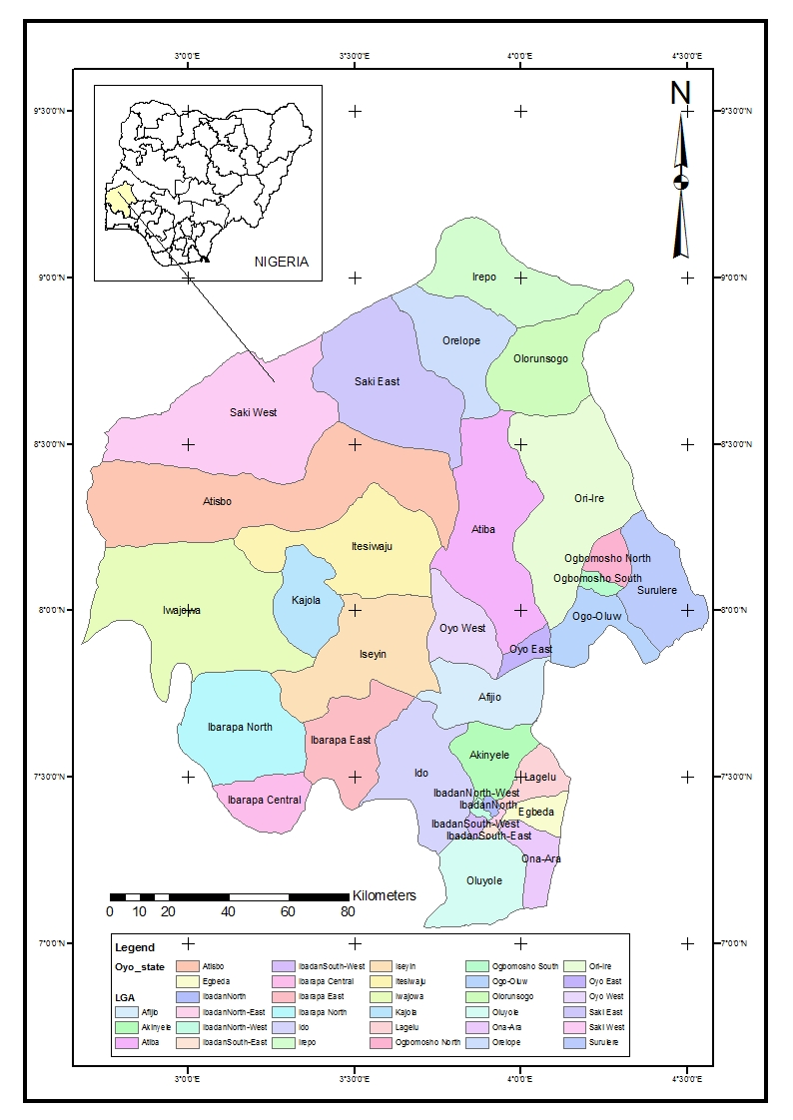

**Figure 1: Map of Oyo State**

The approximate location of the road crashes were estimated from the record obtained from the RS 11.3 Oyo FRSC command. Generally, the record provides an indicative description of the locality where the accident occurred and in some cases, the site was described using the nearest landmarks such as filling stations, roundabouts, stores, markets, garages, institutions or road intersections. Therefore, using the nearest landmarks or locality information provided in the record together with the Google Earth image, the existing digital road network, and the knowledge of the area of study, it was easy to place points on the approximate locations where the crashes occurred (Figure 2).

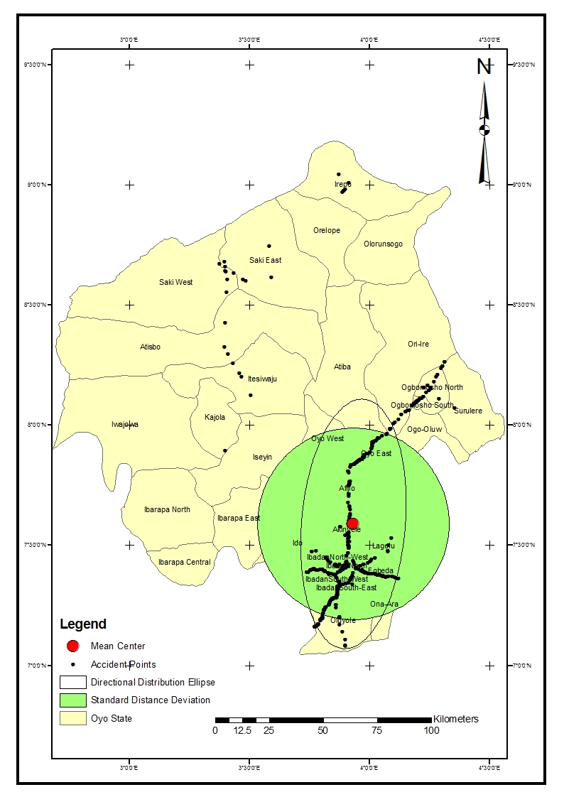

**Figure 2: The mean center, standard distance deviation and standard deviational Ellipse of accident points in Oyo state, Nigeria**

The Google Earth image was particularly helpful because it provides a photographic view of the area of study together with the associated landmarks and road networks. Through the instrumentality of global positioning system (GPS) and the information on locations of crashes for each of the unit commands, the coordinates of crash location were obtained on the geographic coordinates system of the world.

The coordinate locations generated were subsequently exported into ArcGIS where they were plotted as point locations. The point locations, which represent accident crash locations, were overlaid on the road network of the LGAs of Oyo State. This made it possible to clip the Oyo state geo-referenced map within the ArcGIS environment to ascertain where each accident location falls. Therefore, the number of accident points within each LGA was counted and recorded accordingly. The Ibadan satellite imagery (Figure 3) was used as a guide.

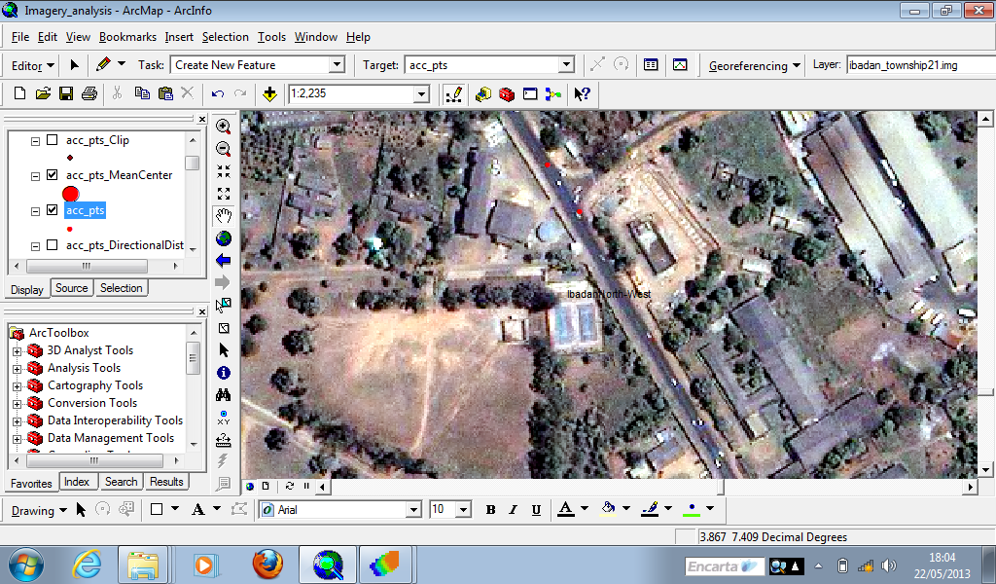

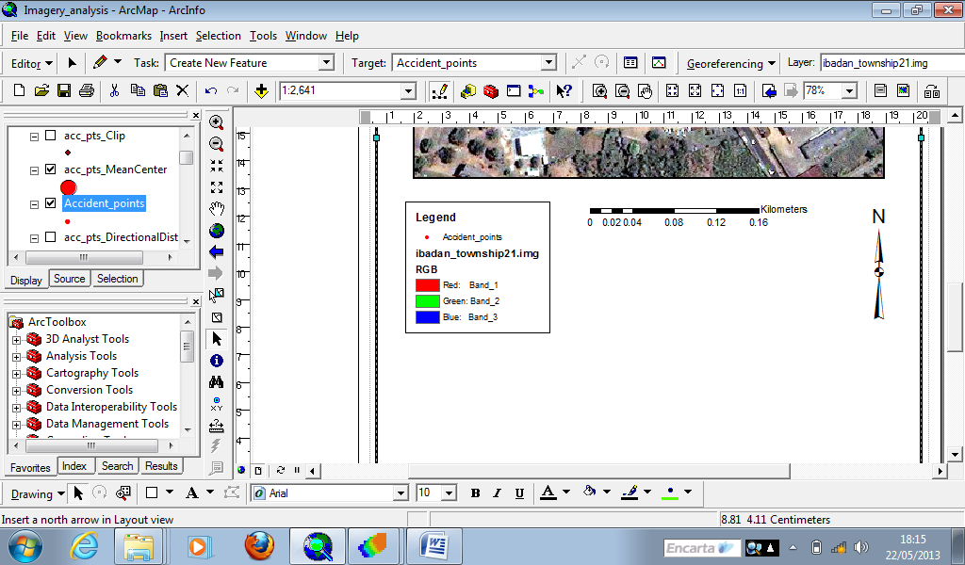

**Figure 3: Portion of the Oyo state quick bird satelite imagery**

The geographic information system (GIS) was used to create polygon shape file (Figure 4) for the study area. The shape file was used to create spatial contiguity weight matrix based on the queen and rook criteria (Tables 1 and 2 respectively). The lengths of the roads and the area encompassing each Local Government Authority were calculated using the measuring tool in the software environment.

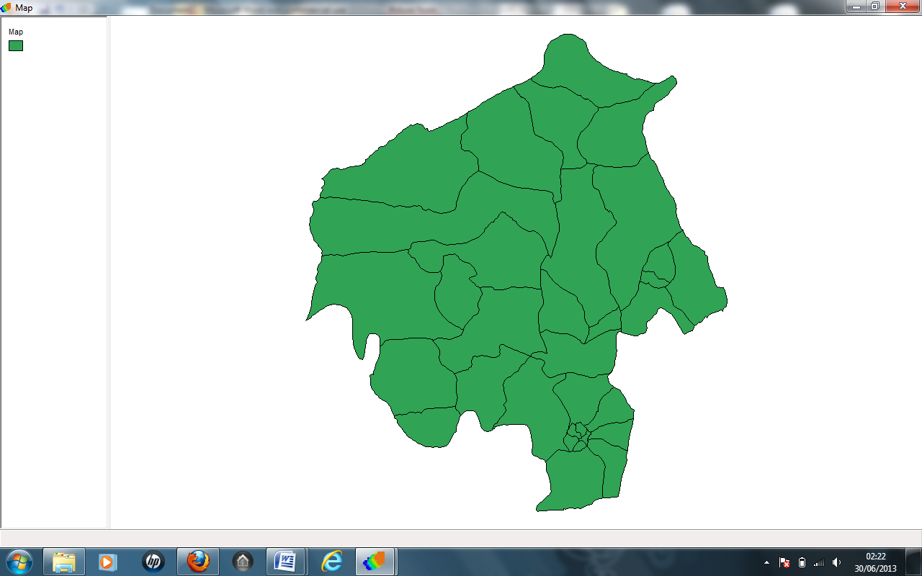**Figure 4: The Oyo state shapefile**

**Table 1: 33 × 33 Queen Weights matrix for Local Government Areas of Oyo state**

|  |  |  |  |  |  |  |  |  |  |  |  |  |  |  |  |  |  |  |  |  |  |  |  |  |  |  |  |  |  |  |  |  |
| --- | --- | --- | --- | --- | --- | --- | --- | --- | --- | --- | --- | --- | --- | --- | --- | --- | --- | --- | --- | --- | --- | --- | --- | --- | --- | --- | --- | --- | --- | --- | --- | --- |
| 0 | 1 | 0 | 0 | 0 | 0 | 0 | 0 | 0 | 0 | 0 | 1 | 0 | 1 | 0 | 1 | 0 | 0 | 0 | 0 | 0 | 0 | 1 | 0 | 0 | 0 | 0 | 0 | 1 | 1 | 0 | 0 | 0 |
| 1 | 0 | 0 | 0 | 0 | 1 | 0 | 1 | 0 | 0 | 0 | 0 | 0 | 1 | 0 | 0 | 0 | 0 | 0 | 1 | 0 | 0 | 0 | 0 | 0 | 0 | 0 | 0 | 0 | 0 | 0 | 0 | 0 |
| 0 | 0 | 0 | 1 | 0 | 0 | 0 | 0 | 0 | 0 | 0 | 0 | 0 | 0 | 0 | 0 | 1 | 0 | 0 | 0 | 0 | 0 | 0 | 1 | 0 | 0 | 1 | 1 | 1 | 1 | 1 | 0 | 0 |
| 0 | 0 | 1 | 0 | 0 | 0 | 0 | 0 | 0 | 0 | 0 | 0 | 0 | 0 | 0 | 0 | 1 | 1 | 0 | 0 | 0 | 0 | 0 | 0 | 0 | 0 | 0 | 0 | 0 | 0 | 1 | 1 | 0 |
| 0 | 0 | 0 | 0 | 0 | 0 | 1 | 0 | 0 | 0 | 0 | 0 | 0 | 0 | 0 | 0 | 0 | 0 | 0 | 1 | 0 | 0 | 0 | 0 | 0 | 1 | 0 | 0 | 0 | 0 | 0 | 0 | 0 |
| 0 | 1 | 0 | 0 | 0 | 0 | 1 | 1 | 0 | 0 | 0 | 0 | 0 | 0 | 0 | 0 | 0 | 0 | 0 | 1 | 0 | 0 | 0 | 0 | 0 | 0 | 0 | 0 | 0 | 0 | 0 | 0 | 0 |
| 0 | 0 | 0 | 0 | 1 | 1 | 0 | 1 | 1 | 1 | 0 | 0 | 0 | 0 | 0 | 0 | 0 | 0 | 0 | 1 | 0 | 0 | 0 | 0 | 1 | 1 | 0 | 0 | 0 | 0 | 0 | 0 | 0 |
| 0 | 1 | 0 | 0 | 0 | 1 | 1 | 0 | 0 | 1 | 0 | 0 | 0 | 1 | 0 | 0 | 0 | 0 | 0 | 0 | 0 | 0 | 0 | 0 | 0 | 0 | 0 | 0 | 0 | 0 | 0 | 0 | 0 |
| 0 | 0 | 0 | 0 | 0 | 0 | 1 | 0 | 0 | 1 | 0 | 0 | 0 | 0 | 0 | 0 | 0 | 0 | 0 | 0 | 0 | 0 | 0 | 0 | 1 | 1 | 0 | 0 | 0 | 0 | 0 | 0 | 0 |
| 0 | 0 | 0 | 0 | 0 | 0 | 1 | 1 | 1 | 0 | 0 | 0 | 0 | 1 | 0 | 0 | 0 | 0 | 0 | 0 | 0 | 0 | 0 | 0 | 1 | 0 | 0 | 0 | 0 | 0 | 0 | 0 | 0 |
| 0 | 0 | 0 | 0 | 0 | 0 | 0 | 0 | 0 | 0 | 0 | 1 | 1 | 0 | 0 | 0 | 0 | 0 | 0 | 0 | 0 | 0 | 0 | 0 | 0 | 0 | 0 | 0 | 0 | 0 | 0 | 0 | 0 |
| 1 | 0 | 0 | 0 | 0 | 0 | 0 | 0 | 0 | 0 | 1 | 0 | 1 | 1 | 0 | 1 | 0 | 0 | 0 | 0 | 0 | 0 | 0 | 0 | 0 | 0 | 0 | 0 | 0 | 0 | 0 | 0 | 0 |
| 0 | 0 | 0 | 0 | 0 | 0 | 0 | 0 | 0 | 0 | 1 | 1 | 0 | 0 | 0 | 1 | 0 | 1 | 0 | 0 | 0 | 0 | 0 | 0 | 0 | 0 | 0 | 0 | 0 | 0 | 0 | 0 | 0 |
| 1 | 1 | 0 | 0 | 0 | 0 | 0 | 1 | 0 | 1 | 0 | 1 | 0 | 0 | 0 | 1 | 0 | 0 | 0 | 0 | 0 | 0 | 0 | 0 | 1 | 0 | 0 | 0 | 0 | 0 | 0 | 0 | 0 |
| 0 | 0 | 0 | 0 | 0 | 0 | 0 | 0 | 0 | 0 | 0 | 0 | 0 | 0 | 0 | 0 | 0 | 0 | 0 | 0 | 0 | 0 | 0 | 1 | 0 | 0 | 1 | 0 | 0 | 0 | 0 | 0 | 0 |
| 1 | 0 | 0 | 0 | 0 | 0 | 0 | 0 | 0 | 0 | 0 | 1 | 1 | 1 | 0 | 0 | 1 | 1 | 1 | 0 | 0 | 0 | 0 | 0 | 0 | 0 | 0 | 0 | 0 | 1 | 0 | 0 | 0 |
| 0 | 0 | 1 | 1 | 0 | 0 | 0 | 0 | 0 | 0 | 0 | 0 | 0 | 0 | 0 | 1 | 0 | 1 | 1 | 0 | 0 | 0 | 0 | 0 | 0 | 0 | 0 | 0 | 0 | 1 | 0 | 0 | 0 |
| 0 | 0 | 0 | 1 | 0 | 0 | 0 | 0 | 0 | 0 | 0 | 0 | 1 | 0 | 0 | 1 | 1 | 0 | 1 | 0 | 0 | 0 | 0 | 0 | 0 | 0 | 0 | 0 | 0 | 0 | 0 | 0 | 0 |
| 0 | 0 | 0 | 0 | 0 | 0 | 0 | 0 | 0 | 0 | 0 | 0 | 0 | 0 | 0 | 1 | 1 | 1 | 0 | 0 | 0 | 0 | 0 | 0 | 0 | 0 | 0 | 0 | 0 | 0 | 0 | 0 | 0 |
| 0 | 1 | 0 | 0 | 1 | 1 | 1 | 0 | 0 | 0 | 0 | 0 | 0 | 0 | 0 | 0 | 0 | 0 | 0 | 0 | 0 | 0 | 0 | 0 | 0 | 0 | 0 | 0 | 0 | 0 | 0 | 0 | 0 |
| 0 | 0 | 0 | 0 | 0 | 0 | 0 | 0 | 0 | 0 | 0 | 0 | 0 | 0 | 0 | 0 | 0 | 0 | 0 | 0 | 0 | 1 | 0 | 0 | 0 | 0 | 0 | 1 | 0 | 0 | 0 | 0 | 1 |
| 0 | 0 | 0 | 0 | 0 | 0 | 0 | 0 | 0 | 0 | 0 | 0 | 0 | 0 | 0 | 0 | 0 | 0 | 0 | 0 | 1 | 0 | 1 | 0 | 0 | 0 | 0 | 1 | 0 | 0 | 0 | 0 | 1 |
| 1 | 0 | 0 | 0 | 0 | 0 | 0 | 0 | 0 | 0 | 0 | 0 | 0 | 0 | 0 | 0 | 0 | 0 | 0 | 0 | 0 | 1 | 0 | 0 | 0 | 0 | 0 | 1 | 1 | 0 | 0 | 0 | 1 |
| 0 | 0 | 1 | 0 | 0 | 0 | 0 | 0 | 0 | 0 | 0 | 0 | 0 | 0 | 1 | 0 | 0 | 0 | 0 | 0 | 0 | 0 | 0 | 0 | 0 | 0 | 1 | 1 | 0 | 0 | 0 | 0 | 0 |
| 0 | 0 | 0 | 0 | 0 | 0 | 1 | 0 | 1 | 1 | 0 | 0 | 0 | 1 | 0 | 0 | 0 | 0 | 0 | 0 | 0 | 0 | 0 | 0 | 0 | 1 | 0 | 0 | 0 | 0 | 0 | 0 | 0 |
| 0 | 0 | 0 | 0 | 1 | 0 | 1 | 0 | 1 | 0 | 0 | 0 | 0 | 0 | 0 | 0 | 0 | 0 | 0 | 0 | 0 | 0 | 0 | 0 | 1 | 0 | 0 | 0 | 0 | 0 | 0 | 0 | 0 |
| 0 | 0 | 1 | 0 | 0 | 0 | 0 | 0 | 0 | 0 | 0 | 0 | 0 | 0 | 1 | 0 | 0 | 0 | 0 | 0 | 0 | 0 | 0 | 1 | 0 | 0 | 0 | 0 | 0 | 0 | 1 | 0 | 0 |
| 0 | 0 | 1 | 0 | 0 | 0 | 0 | 0 | 0 | 0 | 0 | 0 | 0 | 0 | 0 | 0 | 0 | 0 | 0 | 0 | 1 | 1 | 1 | 1 | 0 | 0 | 0 | 0 | 1 | 0 | 0 | 0 | 1 |
| 1 | 0 | 1 | 0 | 0 | 0 | 0 | 0 | 0 | 0 | 0 | 0 | 0 | 0 | 0 | 0 | 0 | 0 | 0 | 0 | 0 | 0 | 1 | 0 | 0 | 0 | 0 | 1 | 0 | 1 | 0 | 0 | 0 |
| 1 | 0 | 1 | 0 | 0 | 0 | 0 | 0 | 0 | 0 | 0 | 0 | 0 | 0 | 0 | 1 | 1 | 0 | 0 | 0 | 0 | 0 | 0 | 0 | 0 | 0 | 0 | 0 | 1 | 0 | 0 | 0 | 0 |
| 0 | 0 | 1 | 1 | 0 | 0 | 0 | 0 | 0 | 0 | 0 | 0 | 0 | 0 | 0 | 0 | 0 | 0 | 0 | 0 | 0 | 0 | 0 | 0 | 0 | 0 | 1 | 0 | 0 | 0 | 0 | 1 | 0 |
| 0 | 0 | 0 | 1 | 0 | 0 | 0 | 0 | 0 | 0 | 0 | 0 | 0 | 0 | 0 | 0 | 0 | 0 | 0 | 0 | 0 | 0 | 0 | 0 | 0 | 0 | 0 | 0 | 0 | 0 | 1 | 0 | 0 |
| 0 | 0 | 0 | 0 | 0 | 0 | 0 | 0 | 0 | 0 | 0 | 0 | 0 | 0 | 0 | 0 | 0 | 0 | 0 | 0 | 1 | 1 | 1 | 0 | 0 | 0 | 0 | 1 | 0 | 0 | 0 | 0 | 0 |

**Table 2: 33 × 33 Rook weights matrix for Local Government Areas of Oyo state**

|  |  |  |  |  |  |  |  |  |  |  |  |  |  |  |  |  |  |  |  |  |  |  |  |  |  |  |  |  |  |  |  |  |
| --- | --- | --- | --- | --- | --- | --- | --- | --- | --- | --- | --- | --- | --- | --- | --- | --- | --- | --- | --- | --- | --- | --- | --- | --- | --- | --- | --- | --- | --- | --- | --- | --- |
| 0 | 1 | 0 | 0 | 0 | 0 | 0 | 0 | 0 | 0 | 0 | 0 | 0 | 1 | 0 | 1 | 0 | 0 | 0 | 0 | 0 | 0 | 1 | 0 | 0 | 0 | 0 | 0 | 1 | 1 | 0 | 0 | 0 |
| 1 | 0 | 0 | 0 | 0 | 1 | 0 | 1 | 0 | 0 | 0 | 0 | 0 | 1 | 0 | 0 | 0 | 0 | 0 | 1 | 0 | 0 | 0 | 0 | 0 | 0 | 0 | 0 | 0 | 0 | 0 | 0 | 0 |
| 0 | 0 | 0 | 1 | 0 | 0 | 0 | 0 | 0 | 0 | 0 | 0 | 0 | 0 | 0 | 0 | 1 | 0 | 0 | 0 | 0 | 0 | 0 | 1 | 0 | 0 | 1 | 1 | 1 | 1 | 1 | 0 | 0 |
| 0 | 0 | 1 | 0 | 0 | 0 | 0 | 0 | 0 | 0 | 0 | 0 | 0 | 0 | 0 | 0 | 1 | 1 | 0 | 0 | 0 | 0 | 0 | 0 | 0 | 0 | 0 | 0 | 0 | 0 | 1 | 1 | 0 |
| 0 | 0 | 0 | 0 | 0 | 0 | 1 | 0 | 0 | 0 | 0 | 0 | 0 | 0 | 0 | 0 | 0 | 0 | 0 | 1 | 0 | 0 | 0 | 0 | 0 | 1 | 0 | 0 | 0 | 0 | 0 | 0 | 0 |
| 0 | 1 | 0 | 0 | 0 | 0 | 1 | 1 | 0 | 0 | 0 | 0 | 0 | 0 | 0 | 0 | 0 | 0 | 0 | 1 | 0 | 0 | 0 | 0 | 0 | 0 | 0 | 0 | 0 | 0 | 0 | 0 | 0 |
| 0 | 0 | 0 | 0 | 1 | 1 | 0 | 1 | 1 | 1 | 0 | 0 | 0 | 0 | 0 | 0 | 0 | 0 | 0 | 1 | 0 | 0 | 0 | 0 | 0 | 1 | 0 | 0 | 0 | 0 | 0 | 0 | 0 |
| 0 | 1 | 0 | 0 | 0 | 1 | 1 | 0 | 0 | 1 | 0 | 0 | 0 | 1 | 0 | 0 | 0 | 0 | 0 | 0 | 0 | 0 | 0 | 0 | 0 | 0 | 0 | 0 | 0 | 0 | 0 | 0 | 0 |
| 0 | 0 | 0 | 0 | 0 | 0 | 1 | 0 | 0 | 1 | 0 | 0 | 0 | 0 | 0 | 0 | 0 | 0 | 0 | 0 | 0 | 0 | 0 | 0 | 1 | 0 | 0 | 0 | 0 | 0 | 0 | 0 | 0 |
| 0 | 0 | 0 | 0 | 0 | 0 | 1 | 1 | 1 | 0 | 0 | 0 | 0 | 1 | 0 | 0 | 0 | 0 | 0 | 0 | 0 | 0 | 0 | 0 | 1 | 0 | 0 | 0 | 0 | 0 | 0 | 0 | 0 |
| 0 | 0 | 0 | 0 | 0 | 0 | 0 | 0 | 0 | 0 | 0 | 1 | 1 | 0 | 0 | 0 | 0 | 0 | 0 | 0 | 0 | 0 | 0 | 0 | 0 | 0 | 0 | 0 | 0 | 0 | 0 | 0 | 0 |
| 0 | 0 | 0 | 0 | 0 | 0 | 0 | 0 | 0 | 0 | 1 | 0 | 1 | 1 | 0 | 1 | 0 | 0 | 0 | 0 | 0 | 0 | 0 | 0 | 0 | 0 | 0 | 0 | 0 | 0 | 0 | 0 | 0 |
| 0 | 0 | 0 | 0 | 0 | 0 | 0 | 0 | 0 | 0 | 1 | 1 | 0 | 0 | 0 | 1 | 0 | 1 | 0 | 0 | 0 | 0 | 0 | 0 | 0 | 0 | 0 | 0 | 0 | 0 | 0 | 0 | 0 |
| 1 | 1 | 0 | 0 | 0 | 0 | 0 | 1 | 0 | 1 | 0 | 1 | 0 | 0 | 0 | 0 | 0 | 0 | 0 | 0 | 0 | 0 | 0 | 0 | 1 | 0 | 0 | 0 | 0 | 0 | 0 | 0 | 0 |
| 0 | 0 | 0 | 0 | 0 | 0 | 0 | 0 | 0 | 0 | 0 | 0 | 0 | 0 | 0 | 0 | 0 | 0 | 0 | 0 | 0 | 0 | 0 | 1 | 0 | 0 | 1 | 0 | 0 | 0 | 0 | 0 | 0 |
| 1 | 0 | 1 | 0 | 0 | 0 | 0 | 0 | 0 | 0 | 0 | 1 | 0 | 0 | 0 | 0 | 1 | 1 | 1 | 0 | 0 | 0 | 0 | 0 | 0 | 0 | 0 | 0 | 0 | 1 | 0 | 0 | 0 |
| 0 | 0 | 1 | 1 | 0 | 0 | 0 | 0 | 0 | 0 | 0 | 0 | 0 | 0 | 0 | 1 | 0 | 1 | 1 | 0 | 0 | 0 | 0 | 0 | 0 | 0 | 0 | 0 | 0 | 1 | 0 | 0 | 0 |
| 0 | 0 | 0 | 1 | 0 | 0 | 0 | 0 | 0 | 0 | 0 | 0 | 1 | 0 | 0 | 1 | 1 | 0 | 1 | 0 | 0 | 0 | 0 | 0 | 0 | 0 | 0 | 0 | 0 | 0 | 0 | 0 | 0 |
| 0 | 0 | 0 | 0 | 0 | 0 | 0 | 0 | 0 | 0 | 0 | 0 | 0 | 0 | 0 | 1 | 1 | 1 | 0 | 0 | 0 | 0 | 0 | 0 | 0 | 0 | 0 | 0 | 0 | 0 | 0 | 0 | 0 |
| 0 | 1 | 0 | 0 | 1 | 1 | 1 | 0 | 0 | 0 | 0 | 0 | 0 | 0 | 0 | 0 | 0 | 0 | 0 | 0 | 0 | 0 | 0 | 0 | 0 | 0 | 0 | 0 | 0 | 0 | 0 | 0 | 0 |
| 0 | 0 | 0 | 0 | 0 | 0 | 0 | 0 | 0 | 0 | 0 | 0 | 0 | 0 | 0 | 0 | 0 | 0 | 0 | 0 | 0 | 1 | 0 | 0 | 0 | 0 | 0 | 1 | 0 | 0 | 0 | 0 | 1 |
| 0 | 0 | 0 | 0 | 0 | 0 | 0 | 0 | 0 | 0 | 0 | 0 | 0 | 0 | 0 | 0 | 0 | 0 | 0 | 0 | 1 | 0 | 1 | 0 | 0 | 0 | 0 | 1 | 0 | 0 | 0 | 0 | 1 |
| 1 | 0 | 0 | 0 | 0 | 0 | 0 | 0 | 0 | 0 | 0 | 0 | 0 | 0 | 0 | 0 | 0 | 0 | 0 | 0 | 0 | 1 | 0 | 0 | 0 | 0 | 0 | 1 | 1 | 0 | 0 | 0 | 1 |
| 0 | 0 | 1 | 0 | 0 | 0 | 0 | 0 | 0 | 0 | 0 | 0 | 0 | 0 | 1 | 0 | 0 | 0 | 0 | 0 | 0 | 0 | 0 | 0 | 0 | 0 | 1 | 1 | 0 | 0 | 0 | 0 | 0 |
| 0 | 0 | 0 | 0 | 0 | 0 | 0 | 0 | 1 | 1 | 0 | 0 | 0 | 1 | 0 | 0 | 0 | 0 | 0 | 0 | 0 | 0 | 0 | 0 | 0 | 1 | 0 | 0 | 0 | 0 | 0 | 0 | 0 |
| 0 | 0 | 0 | 0 | 1 | 0 | 1 | 0 | 0 | 0 | 0 | 0 | 0 | 0 | 0 | 0 | 0 | 0 | 0 | 0 | 0 | 0 | 0 | 0 | 1 | 0 | 0 | 0 | 0 | 0 | 0 | 0 | 0 |
| 0 | 0 | 1 | 0 | 0 | 0 | 0 | 0 | 0 | 0 | 0 | 0 | 0 | 0 | 1 | 0 | 0 | 0 | 0 | 0 | 0 | 0 | 0 | 1 | 0 | 0 | 0 | 0 | 0 | 0 | 1 | 0 | 0 |
| 0 | 0 | 1 | 0 | 0 | 0 | 0 | 0 | 0 | 0 | 0 | 0 | 0 | 0 | 0 | 0 | 0 | 0 | 0 | 0 | 1 | 1 | 1 | 1 | 0 | 0 | 0 | 0 | 1 | 0 | 0 | 0 | 1 |
| 1 | 0 | 1 | 0 | 0 | 0 | 0 | 0 | 0 | 0 | 0 | 0 | 0 | 0 | 0 | 0 | 0 | 0 | 0 | 0 | 0 | 0 | 1 | 0 | 0 | 0 | 0 | 1 | 0 | 1 | 0 | 0 | 0 |
| 1 | 0 | 1 | 0 | 0 | 0 | 0 | 0 | 0 | 0 | 0 | 0 | 0 | 0 | 0 | 1 | 1 | 0 | 0 | 0 | 0 | 0 | 0 | 0 | 0 | 0 | 0 | 0 | 1 | 0 | 0 | 0 | 0 |
| 0 | 0 | 1 | 1 | 0 | 0 | 0 | 0 | 0 | 0 | 0 | 0 | 0 | 0 | 0 | 0 | 0 | 0 | 0 | 0 | 0 | 0 | 0 | 0 | 0 | 0 | 1 | 0 | 0 | 0 | 0 | 1 | 0 |
| 0 | 0 | 0 | 1 | 0 | 0 | 0 | 0 | 0 | 0 | 0 | 0 | 0 | 0 | 0 | 0 | 0 | 0 | 0 | 0 | 0 | 0 | 0 | 0 | 0 | 0 | 0 | 0 | 0 | 0 | 1 | 0 | 0 |
| 0 | 0 | 0 | 0 | 0 | 0 | 0 | 0 | 0 | 0 | 0 | 0 | 0 | 0 | 0 | 0 | 0 | 0 | 0 | 0 | 1 | 1 | 1 | 0 | 0 | 0 | 0 | 1 | 0 | 0 | 0 | 0 | 0 |

Population is defined as the residential population figures for each LGA as reported by NBS for the 2006 population census in Nigeria NBS (2007). Travel density is defined as traffic count for each FRSC unit command divided by total major road length in kilometers within each LGA. Major road length is the total length of roads in kilometres from each settlement to another within each LGA. Area is defined as the area per square kilometre encompassing each LGA. Accident is defined as the total number of cases of vehicle crashes recorded in each LGA whose location was identified by taking the longitudes and latitudes. The logarithms of all the variables were taken for the purpose of this study.

**The Spatial Lag Model**

  1

where,  is an  × 1 vector of the dependent variable (accident cases) for all LGAs. This is formed by observing the total incidence of accidents for each of the 33 LGAs. is the coefficient of the spatial lag. is a known  × spatial weights matrix whose diagonal elements are zero. Two LGAs are said to be contiguous to one another when they share a common border. A spatial weights matrix is defined by using an interaction between the geographical location of each spatial unit and every other location. The neighbourhood contiguity distance between each location and every other location was used.

To develop the spatial weights (contiguity based matrix), the value of 1 was assigned to a LGA when it shares a common border with another, and otherwise the value 0 was assigned. Using the common border, the rook contiguity matrix was used to form a weights matrix. Taking into cognizance the common border and the common vertex border, the queen contiguity matrix was formed. satisfies the condition that is non singular for all ,  is an identity matrix of dimension .  is a weight matrix of  × 1 vector of values for the accident cases summed over all LGAs Anselin (1988) and Smirnov and Anselin ( 2001).

is an  ×  matrix of observations on the explanatory variables, namely area, major road length, population and travel density. is assumed to be of full column rank and its elements are assumed to be asymptotically bounded in absolute value.  is a  × 1 vector of  parameters, representing the 4 regression coefficients for this study.  is an  × 1 vector of normally distributed random error terms, with mean and constant variance, while,, strict exogeneity.

The ordinary least squares estimators are obtained from a regression of the  on and on  respectively. Clearly, the maximum likelihood estimate for  is a function of these auxiliary regression coefficients as well as of. Therefore, the estimate for  can be found directly, once the value for has been determined. These steps can be carried out by standardized regression package. The Geoda software regression package (Anselin, 2005) was used for the study.

**Results and Discussion**

This section gives the estimates and comparability of best fit for the spatial lag regression and classical regression models. Diagnostics for spatial dependence using the queen and the rook based contiguity matrices are equally discussed.

**Spatial Lag Regression Estimates**

Adopting the rook contiguity based spatial weights matrix, the spatial lag model was calibrated (Table 3). The number of observations was 33, number of variables 6, while the degrees of freedom equal 27. The R-squared equal 27%. The mean of the dependent variable (accident) is 0.82 and the standard deviation equal 0.65. The residual variance (sigma – square) is 0.31, while, the standard error estimate (standard error regression) is 0.56.

A limited number of diagnostics are provided with the maximum likelihood lag estimation. First is the Breusch-Pagan test for heteroskedasticity in the error terms. The highly insignificant value of 1.74 (p-value 0.78) suggests that heteroskedasticity is not a serious problem. The second test is an alternative to the asymptotic significance test on the spatial autoregressive coefficient; it is not a test on remaining spatial autocorrelation. The value 2.90 (p-value 0.09) confirms strong significance of the spatial autoregressive coefficient.

The estimated is positive and significant, indicating moderate spatial autoregressive dependence in road traffic accidents. In other words, road traffic accidents tend to be more clustered by LGAs than what would be expected by a random distribution. The number of road traffic accident cases for a given LGA is affected by the road traffic accident cases of the neighbouring LGAs.

Removing the effect of spatial lag variable from the dependent variable (number of accidents), the area of each LGA, residential population, major road lengths and travel densities were used to predict areas with higher than expected future likelihood of accidents.

The sign of the coefficient for the area is positive. There are more accidents in larger LGAs. Every one percent increase in area per square kilometre encompassing a Local Governments Authority will generate 0.02 percent increase in the number of accident cases. This means an increase in the area of administration of LGAs will lead to more accidents in each LGA. Controlling for the spatial lag and the LGAs, population is positively related to the number of accidents occurring within the localities. Indicating that population generates a certain rate of accidents. All other things being equal, LGAs with larger residential populations tend to have more accidents. The coefficient indicates the expected number of accidents for each LGA for every person living in the LGA. A one percent increase in the population will generate 0.74 percent increase in the number of accident cases within each LGA.

Road Lengths characteristic produces a negative coefficient. This means the existence of a freeway link crossing a LGA, inversely impacts the incidence of accident cases for the period. One percent increase in major road length will generate 0.44 percent decrease in the number of accident cases within each LGA.

Travel densities are negatively related to number of accidents. One percent increase in travel densities will generate 0.1 percent decrease in number of accident cases. This suggests inhibiting factors in the sense that traffic generated tend to be associated with fewer crashes. There are a number of possible reasons for this negative coefficient. The high intensity of vehicles in urban areas as a result of economic activities, low concentration of vehicles in less populated areas and the existence of few major roads in rural areas could be responsible for this result.

LGAs with higher than expected future likelihood of accidents include Ibadan North East, Ibadan South East, Ibadan North , Ibadan South West, Egbeda and Ibadan North West.

**Table 3: Some Land Use Predictors of Road Traffic Accidents (Spatial Lag Model)**

|  |  |  |  |  |
| --- | --- | --- | --- | --- |
| **Exogenous Variables** | **Coefficient** | **Standard Error** | **Z-value** | **Probability** |
| Spatial Lag | 0.37 | 0.19 | 1.91 | 0.06 |
| Intercept | -2.31 | 3.38 | -0.68 | 0.50 |
| Area | 0.02 | 0.34 | 0.05 | 0.96 |
| Residential Population | 0.74 | 0.62 | 1.19 | 0.23 |
| Major Road Lengths | -0.44 | 0.55 | -0.79 | 0.43 |
| Travel Density | -0.10 | 0.18 | -0.55 | 0.58 |

**Classical Regression Estimates**

For the classical regression (ordinary least squares) that does not incorporate spatial effect, the estimates shown in Table 4 were obtained. Number of observations (33), number of variables (5), degrees of freedom (28), mean dependent variable – accident (-0.82), standard deviation (0.65), R –squared (0.16%), Adjusted R - squared (0.06%), sum of squared residual (11.639), sigma square (0.42), standard error regression (0.64), sigma square Maximum Likelihood (0.35) and standard error regression Maximum Likelihood (0.59).

The sign of the coefficient for the area is negative. There are more accidents in smaller LGAs. Every one percent decrease in area per square kilometre encompassing a LGA will generate 0.18 percent increase in the number of accident cases. Population is positively related to the number of accidents occurring within the localities. Road Lengths characteristic produces a negative coefficient. One percent increase in major road length will generate 0.24 percent decrease in number of accident cases within each LGA. Travel densities are negatively related to number of accidents. One percent increase in travel densities will generate 0.05 percent decrease in the number of accident cases.

**Table 4: Some Land Use Predictors of Road Traffic Accidents (Classical Regression Model)**

|  |  |  |  |  |
| --- | --- | --- | --- | --- |
| **Exogenous Variables** | **Coefficient** | **Standard Error** | **Z-value** | **Probability** |
| Intercept | -2.39 | 3.90 | -0.61 | 0.55 |
| Area | -0.18 | 0.40 | -0.45 | 0.66 |
| Residential Population | 0.82 | 0.71 | 1.15 | 0.26 |
| Major Road Lengths | -0.24 | 0.64 | -0.38 | 0.71 |
| Travel Density | -0.05 | 0.21 | -0.24 | 0.81 |

It can be deduced that, the sign and magnitude of the coefficients for the spatial lag model and the classical regression model are not the same. For two variables namely, major road lengths and travel densities, the signs are both negative, while the sign for population is positive in the two instances but the sign for area of land encompassing each LGA is different. The magnitudes for all the coefficients are also observed to be different.

**Classical Regression Model versus Spatial Regression Lag Model**

In Table 5, three measures based on the assumption of multivariate normality and the corresponding likelihood functions for the standard regression model are used for comparability with the fit of the spatial lag regression model. The higher the log-likelihood, the better the fit, and the lower the Akaike Information Criterion and Schwarz Criterion, the better the fit.

The log-likelihood of the ordinary least squares increased, compensating the improved fit for the added variable (the spatially lagged dependent variable). Also, the Akaike Information Criteria and Schwarz Criteria improved relative to ordinary least squares, again suggesting an improvement of fit for the spatial lag specification.

**Table 5: Comparability of Model Specification**

|  |  |  |
| --- | --- | --- |
| **Measure** | **Classical Regression Model** | **Spatial Lag Model** |
| Log-Likelihood | -29.63 | -28.18 |
| Akaike Information Criteria | 69.26 | 68.36 |
| Schwarz Criteria | 77.34 | 76.74 |

**Diagnostics for Spatial Dependence**

The tests against spatial dependence in Ordinary Least Squares are given in Table 6. First a Moran’s I test is carried out on the residuals using the correct asymptotic expression for the variance. Next are reported Lagrange multiplier (LM) tests for spatial dependence against (a) spatial error alone, (b) spatial error with spatial lag present (Robust LM error) (c) spatial lag alone, and spatial lag in the presence of spatial error (Robust LM lag). A test for both spatial lag and spatial error (LM SARMA) is also provided.Consider the standard LM-Error and LM-Lag test statistics. If neither of the tests rejects the null hypothesis, stick with the ordinary least squares regression results. If one of the LM test statistics rejects the null and the other does not, then the decision is to estimate the alternative spatial regression model that matches the test statistic that rejects the null. For instance, if LM-Error rejects the null, but LM-Lag does not estimate a spatial error model and vice versa.

When both LM test statistic reject the null hypothesis, proceed to consider the robust forms of the test statistics. Typically, one of them will be significant or one will be orders of magnitude more significant than the other. In this case, the decision is simple, estimate the spatial regression model matching the most significant statistic. If both are highly significant, the model with the largest value for the test statistic will be considered. However, in this situation caution is needed because there may be other sources of misspecification. One obvious action is to consider the results for different spatial weights and/or change the basic that is the non spatial part of the model. The spatial regression diagnostics showed the spatial lag model to be the best fit for this study, using the rook contiguity weights matrix neighbourhood characteristics.

**Table 6: Diagnostics for Spatial Dependence**

|  |  |  |  |  |  |  |
| --- | --- | --- | --- | --- | --- | --- |
| **Weights’ Matrix** | **Moran’s I (Error)** | **LM(Lag)** | **Robust LM(Lag)** | **LM(Error)** | **Robust LM(Error)** | **LM**  **(SARMA)** |
| Queen(MI/DF) | 0.10 | 1 | 1 | 1 | 1 | 2 |
| Rook (MI/DF) | 0.15 | 1 | 1 | 1 | 1 | 2 |
| Queen(Value) | 1.68 | 1.89 | 2.67 | 0.77 | 1.55 | 3.44 |
| Rook (Value) | 2.12 | 3.03 | 2.65 | 1.68 | 1.30 | 4.33 |
| Queen (Probability) | 0.09 | 0.17 | 0.10 | 0.38 | 0.21 | 0.18 |
| Rook (Probability) | 0.03 | 0.08 | 0.10 | 0.20 | 0.25 | 0.11 |

The Moran’s (error) probability value is 0.03, while the Lagrange Multiplier (Lag) has a probability value of 0.08 against the probability value of 0.20 for the Lagrange Multiplier (Error). Since the tests reject the null hypothesis, the ordinary least squares regression results must be ignored.

**Conclusion**

The framework provides a means for linking road accidents with neighbourhoods and exogenous variables. The resulting spatial lag model can be used to identify LGAs with higher than expected future likelihood accident. The sign of the coefficients shows whether a direct or an inverse relationship exist between exogenous variables and the incidence of accidents. The magnitude of the coefficients reveals the extent of the existing relationship between these exogenous variables and the incidence of accidents. The coefficient of the lag variable shows the significance of spatial dependence (spill over effects) across the state. Space is therefore, an important variable and needs to be considered in modelling road traffic accidents.

This procedure is an improvement over the usual traditional method that relies on historical frequencies and political pressure for selecting areas for road maintenance and construction purposes. The calibrated model will serve as a scientific guide to stakeholders to enable the identification of areas with high frequencies of accidents and compliment the efforts of policy and decision makers to promote safety and security on road networks.

The policy implication of our result is that, for the LGAs identified as having higher than expected future likelihood of road traffic accidents; safety and security measures must be administered within these LGAs along with their neighbouring LGAs in order to achieve significant remedial effect. The corresponding neighbours based on the rook criterion for each LGA is given below: Ibadan North East: Ona Ara, Lagelu, Ibadan South West, Ibadan South East, Ibadan North West, Egbeda, Ibadan North.

Ibadan South East: Oluyole, Ibadan North East, Ibadan South West. Ibadan North: Lagelu, Ibadan North West, Ibadan North East, Akinyele. Ibadan South West: Ido, Ibadan North East, Ibadan South East, Oluyole, Ibadan North West. Egbeda: Lagelu, Ona Ara, Ibadan North East. Ibadan North West: Ido, Ibadan South West, Akinyele, Ibadan North, Ibadan North East.

Although, this study has examined a few possible exogenous variables for its investigations, improvements could be made by using more precisely measured variables. Future works could investigate the significance of more trip generators, such as land use activities, generators of economic activities and different employment activities. The causes of accidents such as speed violation, dangerous driving, driving under the influence of alcohol amongst several other factors should be the focus of future works. To enhance succinct investigation into accident characteristics, data for more years should generally be used for accident modelling in the theoretical framework of spatial panels.

Finally, to reduce road traffic accidents, improve safety and security measures and achieve maximum remedial effect; policy designs and decision making on transportation and road networks construction/maintenance should incorporate spill over effects and take cognizance of exogenous variables across the state.

**References**

Aderamo, A.J. (2012). Spatial pattern of road traffic accident casualties in Nigeria. *Mediterranean Journal of Social Sciences* 3.2: 61-72.

Anselin, L. (1988). *Spatial econometrics: methods and models* pp 16-36*,* Kluwer Academic Publishers, Dordrecht, The Netherlands.

Anselin, L. (2005). *Exploring spatial data with Geoda: A workbook* pp 165-212*.* Centre for Spatially Integrated Social Science*.* University of Illinois, Urbana-Champaign. Retrieved Jan. 20, 2013 from http://www.csiss.org/or <http://sal.agecon.uiuc.edu/>.

Chandran, A., G. Kahn, T. Sousa, F. Pechansky, D.M. Bishai and A.A. Gyder (2013). Impact of road traffic deaths on expected years of life lost and reduction in life expectancy in Brazil. *Demography* 50.1: 229- 236.

FRSC (2013). Federal Road Safety Corps (FRSC). Federal Republic of Nigeria. RS11.3 Oyo Sector Command.

FRSC (2014). Retrieved Apr. 02, 2014 from [http://frsc.gov.ng/about- us/what-we-do](http://frsc.gov.ng/about-%09us/what-we-do).

Getis, A. and J.K. Ord (1992). The analysis of spatial association by use of distance statistics. *Geographical Analysis* 24: 189-206.

Harwood, K., C. Mumford and R. Eglese (2013). Investigating the use of metaheuristics for solving single vehicle routing problems with time varying traversal costs. *The Journal of the Operational Research Society* 64.1:34-47.

Kelle, P., H. Schneider, C. Raschke and H. Shirazi (2013). Highway improvement project selection by joint consideration of cost benefit and risk criteria. *The Journal of the Operational Research Society* 64.3:313-325.

Labinjo, M., C. Juillard, O.C. Kobusingye and A.A. Hyder (2009). The burden of road traffic injuries in Nigeria: results of a population based survey. *Injury Prevention* 15.3:157-162.

Levine, N., Kim, K.E. and Nitz, L.H. (1995a). Spatial analysis of Honolulu motor vehicle crashes: I. spatial patterns. *Accident Analysis and Prevention* 27, 5: 663-674.

Levine, N., K.E. Kim, K. and L.H. Nitz (1995b). Spatial analysis of Honolulu motor vehicle crashes: II. Zonal generators. *Accident Analysis and Prevention* 27, 5:675-685.

Moran, P. (1948). The Interpretation of Statistical Maps. *Journal of the Royal Statistical Society B* 10: 243 – 51.

NBS (2007). National Bureau of Statistics (NBS). *Social statistics in Nigeria*. Federal Republic of Nigeria.

Rancourt, M., J. Cordeau and G. Laporte (2013). Long-Haul Vehicle routing and scheduling with working hour rules. *Transportation Science* 47.1:81-107.

Smirnov, O and L. Anselin (2001). Fast maximum likelihood estimation of very large spatial autoregressive models: characteristics of polynomial approach. *Computational Statistics and Data Analysis*. 35:301-319.

Trivedi, A. and D. Rawal (2011). Prevalence of road traffic accidents and driving practices among young drivers. *Healthline* 2.2:72-75.

World Health Organization (WHO) (2004). World report on road traffic injury prevention. *Summary World Health Organization.* Retrieved Mar. 17, 2013 from [http://www.who.int/violence_injury.../ road.../world.../summary_en_rev.pdf](http://www.who.int/violence_injury.../%20%09road.../world.../summary_en_rev.pdf).