**Determinants of PhD Completion Time at the University of Ibadan, Nigeria[1]**

**OLUBUSOYE O.E. & O.D. OLUSOJI**

**Department of Statistics, University of Ibadan, Nigeria**

E-mail: [**busoye2001@yahoo.com**](mailto:busoye2001@yahoo.com)

**Abstract**

The demand for Ph.D degree holders has increased in recent time because of their potential to stimulate national development and promote technological advancement. In view of the desire of the nation to be among the first 20 most developed nations by 2020 and meet the manpower requirement of teaching in the growing tertiary institutions, it is important to examine completion rate and duration of PhD programmes in Nigeria’s foremost university. This paper examined completion time of PhD programme at the University of Ibadan. The main objective is to build a statistical model to explain factors accounting for the variation in completion time. The data used were captured through a survey questionnaire administered by the Postgraduate School, University of Ibadan on 2011/2012 graduating set. Apart from conducting an extensive exploratory analysis on PhD production in the university, a binary logistic regression model was also fitted. The dichotomous responses were: completion on time and completion over time. The fitted logistic regression shows that only 10% of PhDs have predicted probability of completion between 0.4 and 0.94 and factors like gender, Mphil/PhD conversion, marital status and employment status were found to significantly affect PhD completion time.

**Keywords:** PhD degree, completion time, logistic regression

**Introduction**

Postgraduate education also referred to as graduate education in some countries involves learning and studying for degrees, professional or academic certificates or other forms of qualification that requires a first or bachelors degree. The organisation of postgraduate education differs across countries, the Nigerian system adopts the system that broadly divides the programme into two; the Masters and Doctorate Degrees with postgraduate diploma and MPhil also standing as other postgraduate degrees obtainable. Masters students are expected to complete their studies in three semesters, which amounts to one and a half years, but past studies shows that average completion time is around three years. Also, Department of Planning, Budget and Analysis, University of Colorado (2008), Chinelo (2010), Frank (2003) and Afolakemi (2003) reveal an average completion time of seven to eight years for doctoral students.

During the mid-70s, the social demand for education at all levels in Nigeria became so high that educational expansion at all levels of education became one of government's priorities. The 1979 Nigerian Constitution included education in the concurrent legislative list, thus making it possible for state governments to establish universities. This led to the establishment of at least one university in each state of the federation such that by the new millennium, there were over eighty universities in Nigeria with over 15,000 postgraduate students on enrollment (Chinelo 2010).

Statistics over the years shows an increasing rate of enrollment and admission into postgraduate studies across the country, for example, in some selected Nigerian institutions, in the year 2000, there were 2509 postgraduate students, out of which 1814 (72%) were masters students while in the year 2002 there were 3914 postgraduate students, out of which 3145 (80%) were masters students. By 2005, the enrollment dropped to 3546, out of which 1870 (53%) were masters students. In the 80s, there were about 15 Nigerian universities offering courses in postgraduate studies. By 2005, there were about 45 Nigerian universities running postgraduate programmes (Afolakemi, 2003). Statistics for enrolment and output of postgraduate students in Nigerian universities between 1985 and 1989 (NUC, 1994) reveal a staggering disparity between the two. For instance, the data revealed that the 1985/86 academic session recorded a total enrolment of 10,021 postgraduate students, whereas output was only 4,834 students for the 1987/88 session when the students were expected to graduate. This implies an output of 48.24%. In the same vein, the postgraduate output for the 1986/87 intakes was only 42.96%,which declined further in 1989/90 by about 8% with no session hitting an output of 50%. More revealing was the observable disparity in postgraduate output by Discipline. No Discipline made up to 50% output. This trend even appears to be worsening (Chinelo, 2010), but the problem is that more than half of those who started postgraduate programmes finished well beyond the expected stipulated time for graduation.

The Masters and PhD degrees have seen witnessed unprecedented increment in enrollment. The University of Ibadan for example saw a 57% increment in enrollment of postgraduate programmes between the 1990/91 and 1993/94 sessions, 117 of these students registered for doctoral degrees. Also, between the 2000/01 and 2001/02 there was a 5% decrease in enrollment for postgraduate programmes but afterwards there has been a steady increase in enrollment of students for postgraduate programmes (The Data Processing Unit, PG School).

**Time of Completion for Post Graduate Degrees**

The time it takes to finish a PhD varies dramatically from one university to another. Doctorates are typically meant to take four years to complete. However, in UI, most PhD students are still not "doctors" after seven years (The Guardian, Tuesday, October 2007). The time it takes to complete a PhD could either be long or short as some students have been known to finish their PhD within three years while it has also taken some ten years (Frank, 2003).

There has been and still are varying views on how long it should take a PhD candidate to finish his/her programme. It is widely recognised that completion rates and time to completion "relate directly to the quality of the graduate education experience" (CAGS, 2001b, p. 19). Statistics from Cambridge University revealed that about 80% of their PhD students believe it takes an average of 5 to 5.5 years but this is essentially a function of the kind of research the student is undertaking (Cambridge University Website, 2013).

Also, the Department of Chemical Engineering website, 2013 at Stanford University reveals that it takes an average of 4.5 to 5.5 years to finish a PhD degree. There are students known to have concluded their research and bag their doctorate under three years while some don't conclude their research thesis under ten years. The average time taken to wrap up a dissertation in American universities vary from 3.5 to 6 years, some finish a little under ten years while most PhD's are not conferred in Canada until after five to seven years after the bachelor's degree (CAGS, 1997). Further, lengthening times-to-completion coincide with falling completion rates, which now hover around 50% in most disciplines and even lower in the arts and humanities (Baird, 1990).

In Australian universities, PhD students are expected to submit their research thesis between 3 and 4 years of study of full time study, and if a research student is on scholarship, it should last for only a maximum of three years. Australian universities also allow for masters students to upgrade their programme to a PhD degree after their first year of study which most students do, thus, masters programme is not an exit point for most students in the country. If a student did not complete his/her research within the stipulated period, funds from Australian Federal Government's Research Training Scheme (worth tens of millions per year for many Australian universities) are reduced to the university where such student is conducting his/her research (Vladimir, 2010).

In Nigeria, the average time taken to complete a PhD vary across the universities as noted in other nations as well but on the average according to Chinelo (2010), it takes PhD students between seven to eight years to complete their dissertations, a view earlier expressed by Afolakemi (2003). They both contend that the major reason why PhD students in Nigeria abandon their research work was out of obvious frustration but Nigerians who have opportunity to study abroad at postgraduate level usually graduate within the minimum stipulated period(Chinelo,2010).It has also been observed that despite efforts made by those still in the programme, most of them end up making a Ph.D in a minimum average of seven to eight years, as against the stipulated minimum of two to three years in Nigerian universities.

The following research questions are central to this study: What is the average, minimum and maximum time of completion of doctoral students across faculties and programmes at the University of Ibadan? What are the factors responsible for the usually lengthy stay on a PhD programme? Given a set of factors, can finishing a PhD programme on time or over time be predicted?

This study examines the time taken to complete PhD degree and the contributing factors to the prolonged length of stay using the University of Ibadan as a case study. UI has always been a point of reference for other universities in the country in postgraduate studies, so an inquiry into time of completion and its determinants are very important. Therefore, the main objective of this work is to analyse completion time for PhD degrees across faculties and develop a statistical model to predict probability of completion.

The rest of the paper is divided into four sections. Section following this reviews relevant literature on PhD completion time in popular universities around the world, Nigeria inclusive. The third section discusses the methodology used in gathering and analysing the data. The fourth section presents the results of the analysis and the last section gives the concluding remarks.

Bourke, *et al* (2004) used two datasets collected from Australian universities to calculate the degree to which certain variables would predict completion time of research students. These data include information on sex, skill, native English speaking skill, nationality, undergraduate performance, age and nationality of respondents. Regression analysis was carried out to be able to write time of completion as a function of the variables considered. Results of the analysis show that full or part-time enrollment, graduate school deadlines, and having a scholarship greatly influence the time of completion of research students in Australia. Thus, providing full-time scholarships and resolving deadline problems early on would greatly enhance students' abilities to complete their degrees in the required stipulated period. Other variables that contributed significantly to completion time include the candidates age, native English speaking skills, and gender.

David (2012) an associate dean at Queens University, England carried out a survey 1200 PhD students and administered questions relevant to PhD completion time. These questions ranged from challenges that impede candidate’s ability to complete a PhD degree on time, changes to candidates PhD programme that could increase the likelihood of completing his/her degree on time to incentives (financial or otherwise) that could be effective in encouraging completion on schedule. Some 24% of the respondents were spending their fourth year on the PhD programme, 17% third year on the PhD programme while most of them were spending their fifth year or more on the PhD programme. Information gathered on changes that would increase likelihood of candidate’s completion of their programme on time revealed that more respondents favour supervisors, topics, funding, job and mode of study compared to other listed factors. Research funding, provision of jobs, teaching and financial aids are incentives most respondents think would be effective in enhancing quick completion of their programme. Supervisors, funding, family and work are challenges most of the respondents claimed hinder the completion of their PhD programme on time. Information from first year PhD students also revealed that most of them think of an expected time of four years to complete their PhD programme.

Chinelo (2010) precipitated the observation that most postgraduate students in Nigeria tend to graduate long after the stipulated time period for their programmes, indicating an apparent disparity between "what is" and "what ought to be" in running postgraduate programmes in Nigeria. Further, it was hypothesised that the problems encountered delayed the timely completion of studies. Questionnaires were adopted and used to gather information from universities stratified into stratum 1 and 2 on the basis of ownership (federal and state owned). A total of 438 postgraduate students took part in the survey out of which 177 of them were doctoral students. Results obtained reveal that academic problem is rated as the most critical area while personality-related problem is the least critical, the lack of equipment ranked as second most critical. The study went further to show that it takes a minimum of seven to eight years to complete a PhD programme in the country.

Robert (2008) a member of council of graduate schools in the United States of America analysed a set of data gathered from 30 institutions, 5 broad fields, 54 disciplines and information of about 49,000 students gathered from the 1992/1993 session through 2003/2004 session to present an exploratory analysis of PhD completion and attrition. The data collected was divided into two major categories;

1. Completion

* Programme Data: Overall, broad field, discipline
* Gender Data: broad field
* Citizenship/Ethnicity: broad field

1. Attrition

* Programme Data: Overall, broad field, discipline.

The data was gathered through graduate schools in institutions across the country spanning eleven years by monitoring those who enrolled and completed their PhD within the stipulated study period (years). Information gathered showed that Mathematics and Physical Sciences (31%) recorded the highest number of enrollment during the study period, followed by the Social Sciences (21%) while Arts and Humanities (12%) recorded the least enrollment rate. Also, 5% of the Cohort finished their PhD within three years, it took 46% exactly seven years to complete their dissertations, while 57% (which is the highest) finished within ten years or more. A cross section of completion rates were examined across faculties, it revealed that Arts and Humanities had more respondents who completed their programme within three years, closely followed by Mathematical and Physical Sciences while Life Sciences and Engineering had more respondents who finished their PhD in ten years. Amongst disciplines in engineering faculty, Civil Engineering had 73% of its students completing their dissertations within ten years while Electrical Electronics Engineering had 56%, Computer Science had 41% completion rate within ten years, Chemistry had 62%, the highest in the Science Faculty. Generally, males tend to finish their dissertations within ten years compared to their female counterparts across the faculties studied but most of them completed their programme in their sixth year. Also, international students were shown to finish their dissertations earlier than domestic students.

For attrition, the information gathered reveals that Mathematical and Physical Sciences had the highest attrition rates over a ten year period with the highest recorded in the tenth year which was 37%. Arts and Humanities experienced the lowest attrition rate at baseline but attrition increased rather rapidly as the year went by and attrition rate was observed to be around 32% in the tenth year, the second highest after Mathematics and Physical Sciences.

Apparently, from the foregoing literature, Ph.D completion time varies across institutions and countries and the underlying determinants also vary. More evidences from empirical studies are still needed to understand this phenomenon and hence this study will add to the volume by examining the situation in the University of Ibadan.

**Methodology**

Logistic regression is basically a statistical tool that determines the impact of multiple independent variables presented simultaneously to predict membership of one or other of the two dependent variable categories. Its central mathematical concept is the logit, the natural logarithm of an odd ratio (which is the ratio of favourable to unfavourable outcomes or the ratio of a probability to its complement). To achieve our objective of building a model that will predict whether a candidate will finish on time or beyond stipulated time based on some predetermined factors, logistic regression is the most appealing technique. The factors considered are: gender (*g*), age (*age*), marital status (*ms*), supervisor status (*ss*), faculty (*f*), employment status (*es*) and M.Phil/PhD conversion (*mpc*).

Thus, the logistic model is specified explicitly as

+ *e*

where *β0* is the intercept and *βi* i=1, 2, …, 7 are parameters/coefficients to be estimated, πi(dependent variable or so to speak in this case) is the probability of completing PhD programme on time. The last term *e* is a well-behaved error term.

The predictor probability is then given as where *β’* is a vector of the coefficients and *Xi* is the matrix of the independent variables. The Wald’s chi-squared test statistic is used to test for the statistical significance of each coefficient estimated. In order to see how well the fitted model fits the data, a measure of discrepancy between the actual and fitted values is observed by the deviance statistic. This statistic works like the likelihood ratio test that compares the model of interest with a saturated model that has one parameter for each observation.

Unlike linear regression models, where *R2*(proportion of variation in the dependent variable explained by the model) has a clear definition, none of the *R2* in logistic regression has the meaning that is labeled in linear regression model thus test for overall significance, significant of estimated coefficients and goodness of fit test is used to evaluate the logistic regression model(Cox and Snell; 1989, Nagelkerke; 1991).

Notably, logistic regression predicts probabilities since it is a natural logarithmic transformation of odds, thus the resultant probabilities are revalidated with the actual outcomes to see if high probabilities are indeed associated with an event or a group in the dependent variable while low probabilities are associated with the other. The degree of agreement between predicted probabilities and actual outcomes is expressed in a classification table or a measure of association. The three popular methods of association used are Kendall’s Tau-*a,* Goodman-Kruskal’s Gamma and Somers’s *D* statistic.

**Results and Discussion**

The data used for this work was extracted from questionnaires distributed to students who completed their PhD research in the 2011/2012 session. These questionnaires were actually administered by the postgraduate school and respondents provided answers to questions raised. The survey covered 187 respondents, the information solicited is in three categories, these are:

* Demographic: Data on age as at last birthday, sex, marital status and employment status.
* Academic: Data on faculty, department, supervisor status, university where first degree was obtained, university where masters degree was obtained, year of entry into the programme, year of completion, number of semesters spent on the programme, part time/full time mode of study and Mphil/PhD conversion.
* Others: These are actually derived from the responses provided. For instance, completion time is obtained by taking the difference between the year of entry and year of completion.

The completion time computed is coded into two distinct categories (on time and beyond stipulated time) using a benchmark of six years. That is, those who completed their programme under or exactly six years are deemed to have finished on time while those who finished from seven years and above are considered to have finished late (beyond stipulated time). This dichotomous variable (on time and beyond stipulated time) is used as the dependent variable for the logistic regression.

**Descriptive Statistics**

Generally, it takes a minimum of 4 years and a maximum of 21 years to complete a PhD programme in UI. On average it takes approximately 9 years to complete.

**Min. 1st Qu. Median Mean 3rd Qu. Max.**

4.000 7.000 9.000 9.101 10.250 21.000

A mere 13% completed on time and 84% of them are males. The box-plot below shows that variation in completion time is high among males compared to females and there exists outliers in both sexes. Of keen interest here is a female respondent who spent 21 years to complete her PhD.

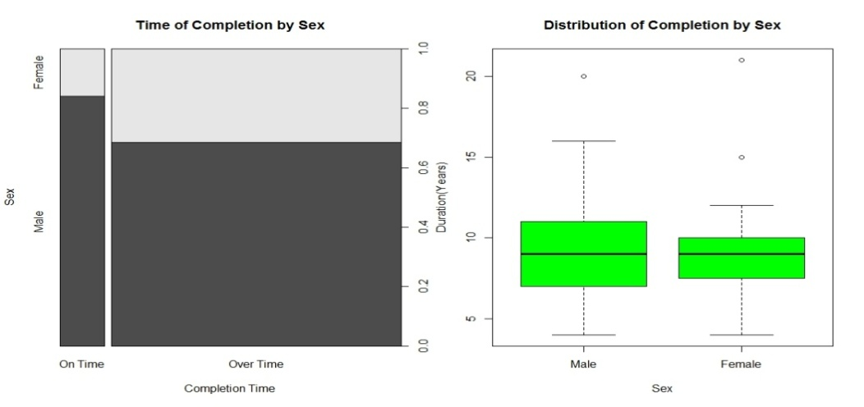

**Figure 1: Time of Completion by Sex**

**Completion Time and Marital Status**

The analysis reveals that majority (86%) of those who completed are married (it is not clear whether they got married before entering or during the programme). Notably, only 9% of the married graduating students managed to complete on time. For the singles, a good proportion, 45% completed on time. The implication is that marital status has a direct impact on completion time. The box-plot overleaf reinforces this position as the median completion time for those who are single is seven years compared to nine years observed for those who are married.

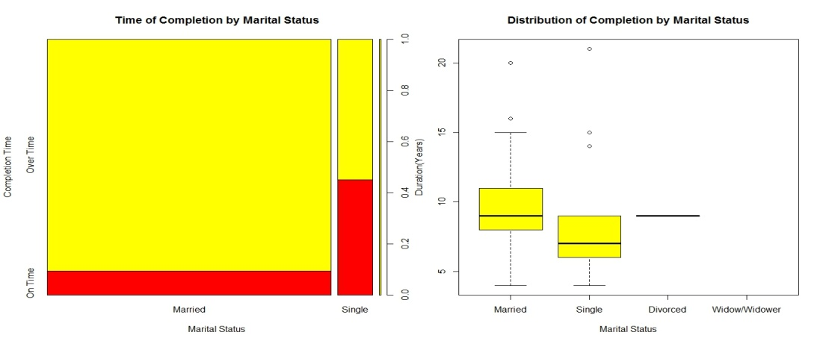

**Figure 2: Time of Completion by Marital Status**

**Completion Time and the Rank of Supervisor**

Professors in UI supervised 45% of all completed Ph.D theses, but a paltry 18% of their supervisees managed to finish on record time. Only 2% of the respondents claimed to have been supervised by Lecturer I,none completed on time. The median time of completion is nine years irrespective of the rank of the supervisor.

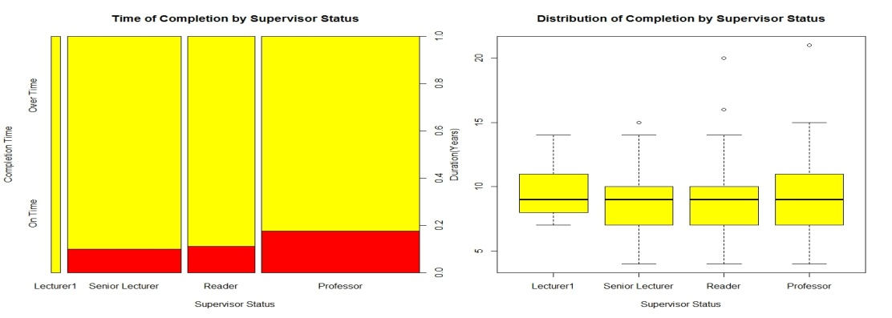

**Figure 3: Time of Completion by Supervisor Status**

**Completion Time and Employment Status**

The analysis of those who combined employment with Ph.D work shows that only 11% managed to complete on time while 30% of those not in any form of employment completed the programme on time. On the average (using median), employed Ph.D student spend nine years to complete as against seven years for those not in any form of employment. Most striking is the outlier cases observed among those in employment with cases of more than 20 years of completion time.

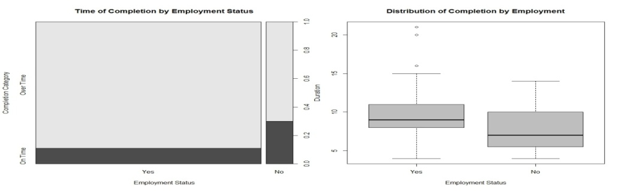

**Figure 4: Time of Completion by Employment Status**

**Completion Time and Employment Nature**

Contrary to expectation, the analysis shows that respondents who are working in academic/research institutions and those working in non-academic/administrative environment do not have any advantage over one another as regards completing on record time. 11.8% of those employed in academic/research institutions completed on time. Similarly, 12.5% of those employed as non-academic/administration staff completed on time. Both categories also have median of nine years of completion time. The box-plot shows cases of striking outliers preponderant among students working in academic/research institutions.

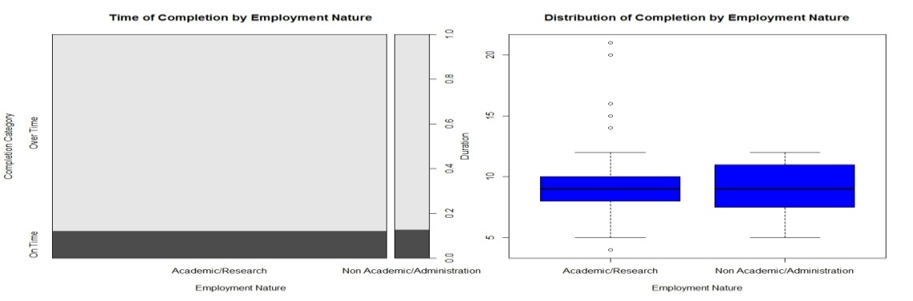

**Figure 5: Time of Completion by Nature of Employment**

**Completion Time and Mphil/PhD Conversion**

A paltry 6% of those who did conversion examination actually completed on time compared to 19% for those who did not. Also, the median years of completion time for both are nine years.

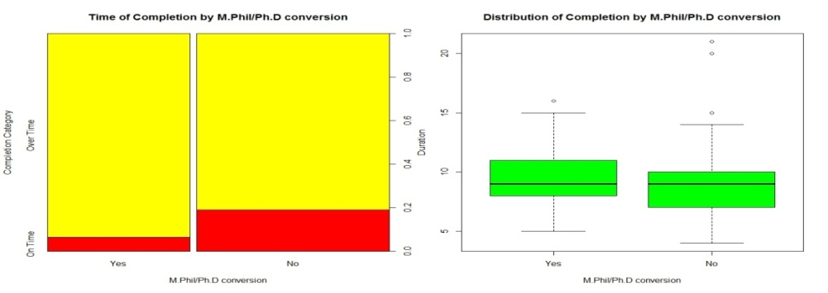

**Figure 6: Time of Completion by Mphil/PhD Conversion**

***Completion by Faculty***

Faculties of Public Health, Pharmacy and Technology came out distinctively. While the Faculty of Public Health records 100% on-time completion rate the other two show 100% beyond the stipulated time completion rate. In other words, Ph.D is completed on-time in the Faculty of Public Health while in the Faculties of Pharmacy and Technology; it is completed after extra years. The median completion time in the Faculties of Public Health is five years; Veterinary Medicine, eight years; Education, nine years; Science, nine years; Social Science, nine years; Arts, nine years; Agric., nine years; Basic Medical Sciences, 9.5 years; Technology, ten years and Pharmacy, ten years.

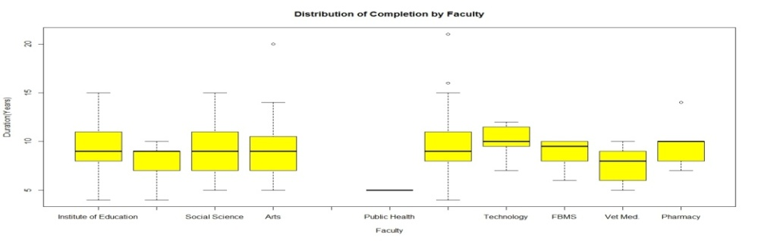

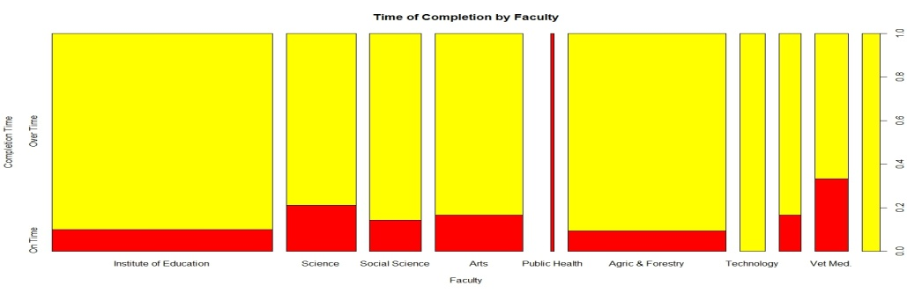

**Figure 7: Time of Completion by Faculty**

**Fitted Logistic Regression Model**

Following the results of the descriptive statistics discussed above, inferential analysis is further explored to enable us make statements that can be supported with some degree of certainty. The variables considered as likely determinants of completion time include: *gender*, *marital status*, *age*, *number of supervisors*, *conversion examination*, *faculty*, *employment status* and *nature of employment* (academic or non-academic).

Table 1 summarises the results of the two fitted models. Model 1 is the general model while Model 2 excludes variables not significant in the first. Using the minimum AIC as selection criterion, Model 1 is preferred. The estimated coefficient for gender is positive and significant at 5% level of significance, which shows that being male increases the probability of completing PhD degree on time. Marital status is also significant, but with a negative coefficient which means married PhD students have a reduced chance of completing their PhD degree on time. Though the coefficient for age is not significant, the negative sign indicates that the older the student, the less the probability of completing PhD on time. The number of supervisors supervising a PhD candidate is not significant but is positively related to the probability of completing on time. Going through Mphil/PhD conversion examination significantly reduces the chance of completing the programme on time.

Faculties such as education that are not listed in Table 1 are found to have predicted perfectly the time spent on the programme because the completion status does not vary with them. In such circumstances, they are automatically dropped during analysis. Faculties of Science, Social Science, Agriculture and Forestry and Basic Medical Sciences have negative but not significant coefficients which imply that their PhD students have a reduced probability of completing on time, whereas Arts and Veterinary Medicine with positive coefficients but also not significant have high chance. Being employed is also found to have reduced the probability of completing PhD programme significantly. The academic status/rank of a supervisor is also related to the probability of completing PhD on time though not significantly. Students who are supervised by Senior Lecturers have a reduced chance of completing the programme on time while those supervised by readers and professors have a higher chance.

**Table 1: Fitted Logistic Regressions**

|  |  |  |
| --- | --- | --- |
| **Regressors** | **Model1 Coefficients** | **Model2 Coefficients** |
| Gender | 2.895876 ** | 2.079*** |
| Marital Status | -3.726677 *** | -2.669*** |
| Age of Respondents | -0.0036632 |  |
| Number of Supervisors | 0.3081855 |  |
| Mphil/PhD conversion | -2.168537 ** | -1.163* |
| Senior Lecturer | -0.7772209 |  |
| Reader | 0.1911407 |  |
| Science | -0.2022666 |  |
| Social Sciences | -0.4698122 |  |
| Arts | 0.288562 |  |
| Agric & Forestry | -0.4174476 |  |
| Basic Medical Sciences | -0.7371689 |  |
| Vet. Medicine | 0.9300724 |  |
| Employment Status | -6.036372** | -1.184* |
| Nature of Employment | 2.538283 |  |
| Intercept | 2.764129 | 0.042 |

** *significant at 1%, **Significant at 5%, and *Significant at 10%

Model1: AIC: 105.4331, BIC: 153.0608, Log Likelihood: -36.716543, Prob > chi2: 0.0006, Pseudo R2: 0.3480

Model2: AIC: 122.086, BIC: 138.0785, Log Likelihood: -56.043, Prob > chi2: 0.0000, Pseudo R2: 0.2087

To check if model1 fits the data well the Hosmer – Lemeshow test is conducted. The null hypothesis is that model1 fits the data. The following statistics are obtained.

Number of observations = 162

Number of groups = 10

Hosmer-Lemeshow chi2(8) = 8.34

Prob > chi2 = 0.4005

The test suggests that the model fits well. This is further supported by the Lowess Smoother plot (figure 8) which shows that the predicted probabilities (red line) does not really deviate from the moving average of the proportion of cases that are one (green line). Table 2 shows that the predicted probabilities in the sample range from 0.001 to 0.935, with a mean predicted probability of completing PhD on time to be 0.142.

**Table 2: Summary of Predicted Probabilities**

|  |  |  |  |  |
| --- | --- | --- | --- | --- |
| **Variable** | **Obs Mean** | **Std. Dev.** | **Min** | **Max** |
| Prlogit | 1620.1419753 | 0.1866537 | 0.0010851 | 0.9345437 |

0

.2

.4

.6

.8

1

Duration

0

.2

.4

.6

.8

1

Pr(status)

bandwidth = .8

**Figure 8: Lowess Smoother**

moving average of the proportion of cases that are one

predicted probabilities

Figure 9 is the dot plot of the predicted probabilities for our sample. The plot clearly shows that the predicted probabilities for PhD completion time in UI is generally low. Only about 10% have predicted probabilities between 0.4 and 0.94.

Logit: Pr (status)

0

.2

.4

.6

.8

1

0

10

20

30

40

Frequency

**Figure 9: Lowess Smoother**

**Conclusion**

This study examined the determinants of PhD completion time at the University of Ibadan. The methodology entailed descriptive analysis of completion time in relation to factors such as gender, age, conversion examination, supervisor’s rank or level, faculty, and others. A logistic regression model was fitted to be able to determine the nature of the relationship between examined factors and the probability of completing PhD on time or otherwise.

The findings showed it took an average of nine years to complete a PhD degree in UI with an expected minimum of four years. Factors that influenced PhD completion time significantly were: marital status, gender, MPhil/PhD conversion examination, and employment status. The predicted probabilities of PhD completion time were generally low for the sampled respondents.

**References**

Abdulrahman, Y. M. (2012). Historical Development of Higher Education in Nigeria. EDU 2011 Lecture Series. Dr. Abdulrahman Y. M. official website. Retrieved 4th April 2013 from the World Wide Web[http://yusufmaigida.com.ng/scholastic/historicaldevelopmet- of-higher-education-in-nigeria/](http://yusufmaigida.com.ng/scholastic/historicaldevelopmet-%09of-higher-education-in-nigeria/)

Academic (2012). What is the average time to complete a PhD. Online Academic Forum. Retrieved 4th April 2013 from the World Wide Web <http://academicjoy.net/phdcandidate>

Afolakemi, O.O. (2003). Postgraduate students’ supervision and training in Nigerian tertiary institutions: A comparative study. Towards quality in African higher education. 319 -327.

Bridget, M. (2000). The Growth of the new PhD. Website of American Psychological Association. Retrieved 24th March 2013 from the World Wide Web <http://www.apa.org/monitor/nov00/phd.aspx>

Britta, B. (2012). Trends and Challenges in Canadian Graduate Education. TRANS-DOC Closing Seminar, University of Alberta.

Brouke, S. (2004). Attrition and completion times of PhD candidates. Paper presented at the annual AARE Conference, Melbourne. Australia.

Bryan, G. and S. Gardner (2012). The Part-time Doctoral Student Experience***.*** International Journal of Doctoral Studies **7**, 63 – 74.

Baird, L.L. (1990). Disciplines and doctorates: The relationships between program characteristics and the duration of doctoral study. Research in Higher Education, 31*,* 369-385.

Chao, Y. et *al.* (2002). An introduction to logistic regression analysis and Reporting. The Journal of Education Research, **10,** 3 – 12.

Chinelo, O.D. (2010). An analysis of problems encountered by post- graduate students in Nigerian universities. Journal of Social Science, **22(2)** 129 – 137.

Canadian Association for Graduate Studies (CAGS), (1997). Time to completion and cohort completion percentages by discipline: A consolidation of data for the 1985-1988 cohorts. St. John's, Canada: Author.

Canadian Association for Graduate Studies (CAGS), (2001b). Brave New Worlds: Graduate Education for the 21st Century. Ottawa: University of Ottawa.

Christian, K. and Z. Achim (2008). Applied econometrics with R. Springer; New York, USA, pp 129 – 133

Christopher, M. (2007). Logistic regression with R***.*** Unpublished Lecture Note.

College Confidential (2007). Average time to get a PhD**.** College Confidential official website. Retrieved on 4th April from the World WideWeb[http://talk.collegeconfidential.com/graduateschool/3889 74-average-time-get-ph-d.html](http://talk.collegeconfidential.com/graduateschool/3889%0974-average-time-get-ph-d.html)

Council of Graduate Schools (2008). Ph.D. completion project: Policies and practices to promote student success. Executive summary, USA.

Council of Graduate Schools (2012). The Crucial Issue of doctoral non completion. Council of Graduate Schools Website, USA. Retrieved 4th April 2013 from the World Wide Web http://www.Cgsnet .org/cgs-occasional-paper-series/university-georgia/

Cox, D. R. and E.J. Snell (1989). Analysis of binary data. Second Edition. Chapman & Hall.

David, R. (2012). Time to completion PhD student survey***.*** ITC Survey Presentation, Queens University, England.

Dalgaard, P. (2008). Introductory Statistics with R, Springer; New York, USA,pp 227 - 239

Frank, J.E. (2003). PhD completion in Canadian universities. Dalhousie University, Halifax, Nova Scotia; Canada, pp 5 – 38.

Lea, W. (2008). Ten years to a doctorate? Not anymore*.* American Psychological Association Website. Retrieved 4th April 2013 from the World Wide Web http://www.apa.org /gradpsych/2008/03/ cover-doctorate.aspx

Léo, C. (2013). PhD completion rates and times to completion in Canada. Margin Notes Website. Retrieved 4th April from the World Wide Web <http://universityaffairs.ca/blog/MarginNotes>

Nagelkerke, N. J. (1991). A note on a general definition of the coefficient of determination. Biometrika, 78: 691 – 692.

National Science Foundation, (2006). Time to Degree of US Research Doctorate Recipients. National Science Foundation Website. Retrieved 4th April from the World Wide Web http://www. nsf.gov/statistics/infbrief/nsf06312/

NUC, (1994). National Universities Commission 25th Anniversary Publications, NUC Office, Abuja.

New Advent, (2009). Doctor. Catholic Encyclopedia. Retrieved on 4th April from the World Wide Web [http://www.newadvent.org/ cathen/05072b.htm](http://www.newadvent.org/%20%09cathen/05072b.htm)

Newsom Data Analysis II, (2012). Logistic Regression. Unpublished Lecture Note.

Marian, P. and R. Gordon (nd). The Unwritten Rules of PhD Research. Open University Press.

Postgraduate School, University of Ibadan (2013). Retrieved on 4th of March from the World Wide Web [http://pgschool.ui.edu.ng/ about/](http://pgschool.ui.edu.ng/%20%20%09about/)

Richard, M. (2013). Logistic Regression using R and S-Plus. Retrieved on 5th June 2013 from the World Wide http://bioinformatics. well.ox.ac.uk/lectures/.

Robert, S. (2008). Ph. D. completion and attrition: Analysis of baseline data. A paper presented at NSF Workshop, Council of Graduate Schools, USA.

Sophia, R.H. and E. Brian (2004). A Handbook of Statistical Analysis Using Stata. CRC Press LLC. p. 106 – 119.

Stanford University (2013). Research at Stanford.http://www. Stanford. edu/research/.

The Economist (2010). Doctoral Degrees, the Disposable Academic. The Economist Official Website. Retrieved 4th April 2013 from the World Wide Web <http://www.economist.com/node/17723223>.

The Guardian (2007). A Race to the Finish, 2nd of October 2007.

United States Embassy in Nigeria. (2012). Nigeria education fact sheet**.** Economic Section, United States Embassy in Nigeria, Abuja.

University of Colorado (2008). Graduation rates for master’s and doctoral students (2008 update). Office of Planning, Budget and Analysis, University of Colorado Official Webpage. Retrieved 4th April 2013 from the World Wide Web <http://www.colorado.edu/pba/>.

University of Cambridge (2013). Research at Cambridge. http:// www.cam.ac.uk/research.

Vladimir, J. (2010). Potential predictors of timely completion among dissertation research students at an Australian Faculty of Sciences***.*** *International Journal of Doctoral Studies***, 5**, 1 – 13.

World Map (2013). Education in Nigeria. Retrieved on 30th March 2013 from the World Wide Web <http://mapsofworld.com>.

1. We gratefully acknowledge the assistance of the Dean, Postgraduate School, University of Ibadan, Prof. A.O. Olorunnisola for approving the release of the data used for this study.