**Evolving Approaches to University Education in Africa: Recent Examples from Ghana**

**1*KRANJAC-BERISAVLJEVIC G. & 2R. ABAIDOO**

**1University for Development Studies, Tamale**

**2Kwame Nkrumah University of Science and Technology, Kumasi**

**\*Email: novagordanak@gmail.com**

# **Abstract**

African university education is under the mounting pressure to answer to challenges and demands of the 21st century, such as training of large young population in practically oriented programmes and courses, as well as arresting the brain drain which affects the continent. Training and appropriate education of available human resources are essential for many aspects of life, including food security and improvement of living standards. Further, an educated and informed population is fundamental to policies and strategies for reducing poverty, excessive population growth, environmental degradation and other factors often responsible for low levels of development. Two evolving models of Ghanaian university education were the focus of this paper. Community-oriented practical education offered by the University for Development Studies (UDS) was an approach used to attract significant numbers of highly trained, young people to remain in rural areas of Ghana. Their dedication to work in the least developed parts of the country and ability to solve numerous problems in the surrounding environment have earned this programme high esteem within and outside the country. The second model, currently under the development by several Ghanaian public universities, is the concept of doctoral colleges for essential training of PhD candidates in deficit fields, such as mathematics, computer sciences and other relevant key disciplines.

**Keywords:** University Education, Community Development, Ghana

# **Introduction**

Tertiary education of African students has frequently provided not only capacity building for the young and active parts of the population, but also an opportunity to leave the continent, serving almost as “passport” for departure to industrialized countries of Western Europe and North America. The United Nations Economic Commission for Africa and the International Organization for Migration (IOM) estimated that 67,000 educated Africans left the continent for industrialized countries between 1960 and 1984, and since 1984, this figure is about 20,000/annum (Mutume, 2003). Black *et al.*(2003) suggest that 15 per cent of Ghanaians with university education have migrated to the United States and another 10 per cent to other Organisation for Economic Cooperation and Development (OECD) countries.

At present, about a third of African scientists live and work in developed countries. Africa currently produces 1.4 percent of the articles published in peer-reviewed international journals (NASAC, 2009). This corresponds with Mamdani (2002) which states that of the 900 African titles produced in 2001, only 1.5 per cent were published in Africa, and, of these, 65 per cent were published in South Africa, 25 per cent in North Africa, with only 10 percent coming from the rest of the continent. This situation clearly reflects both a woeful lack of research publications, as well as urgent need for transforming the learning process in Africa.

There is general recognition in African tertiary institutions that radical reforms are necessary to change this situation. Universities have traditionally been a source of knowledge and innovation in most societies and the research conducted by these institutions is critical to technological and scientific advancement, growth, and development (Ramphele, 2004). University education is an important cornerstone for economic development and has, in recent times, shown strong impact on poverty reduction. Evidence links economic productivity, national wealth and competitiveness in developed and emerging nations to production, application and management of new knowledge (Powell and Snellman, 2004, Gibbons, 1994, Castells 2000, in: Doh, 2012).The OECD reinforces this position by stating that “knowledge and the creation of knowledge are perceived to be the essential generators of material benefits for individuals and nations…” (Hazelkorn, 2005, in: Doh, 2012).

Thus, most African universities are presently repositioning themselves to respond to the challenges of the 21st century educational requirements and be re-invented as reliable centres of excellence, relevant to the national development. This is underscored by the Abuja Declaration (AAU, 2009), which recognises the role of education required in transforming and improving conditions of learners and the community, and being crucial to the achievement of sustainable development.

# **Issues University Education in African Countries**

The growth of enrolment in university education is faster in sub-Saharan Africa (SSA) than any other region of the world over the last four decades. While fewer than 200,000 tertiary students enrolled in the region in 1970, this number was over 4.5 million in 2008. Despite this tremendous increase, the number of young people completing secondary school education is far larger than enrolment in tertiary education. In 2008, enrolment in tertiary institutions in SSA was about 6% (6.2% for Ghana), when compared to the global figure of 26%. In 2008 alone, 223,000 students from (SSA) enrolled in university institutions outside their countries. Nearly two-thirds (65.1%) of these students studied in North America and Western Europe (UISFact sheet, 2010).

## Situation in Ghana

Ghana is coping with this demand for education similarly as other countries in SSA-by increasing admissions to the country’s university system. Between 1990 and 2004, enrolment in the public tertiary institutions increased by 550 percent, from 13,415 to 87,929. Concurrently, there is a rapid increase in the number of public and private universities, at present about 70, comprising 9 public registered foreign, one regional and 51 private tertiary institutions offering degree programmes (Manuh et al., 2007, NAB official website, 2013). There is also evidence that operational efficiency of universities in Ghana has improved over time (Varghese, 2013).

The first formal higher educational institution in the country was the University College of the Gold Coast in 1948, formed as a college of the University of London, to offer programmes in the humanities, arts, sciences and agriculture. The Kumasi College of Technology was established in 1952, with a mandate to foster programmes in science and technology. After Ghana’s independence in 1957, both institutions were upgraded to full university status in 1961. In 1962, the University College of Cape Coast was established to provide specialized training for teachers of science and mathematics in the secondary and technical schools. In 1992, two more publicly funded universities were established: the University of Education, Winneba (UEW) in the central region and the University for Development Studies (UDS) in Northern Ghana (Manuh *et al*., 2007). The UDS educational model is discussed in more detail below.

# **Mandate and Vision of the University for Development Studies**

An explicit purpose and corresponding mandate of UDS is to bring university education closer to the regions of northern Ghana, where educational opportunities and facilities are generally poor (Kaburise, 2003). UDS was established to help develop tertiary education in the least developed parts of the country. It seeks to attain its vision by:

* Promoting equitable and socio-economic transformation of communities through practically-oriented, community-based, problem-solving, gender-sensitive and interactive research, teaching, learning and outreach programmes.
* Providing higher education to persons suitably qualified for, and capable of benefiting from it.
* Positioning itself as a national asset in the facilitation of life-long learning.
* Developing its Information and Communication Technology infrastructure as the driving force for the education of more people more rapidly, and the improvement of efficiency and academic quality in order to advance community and national development.

UDS philosophy is pro-poor oriented, geared towards self-development and sustainability. The university currently has four main campuses at Wa, Navrongo, Tamale and Nyankpala, with faculties of Agricultural Technology (established first at Nyankpala), Renewable Natural Resources, Medicine and Health Sciences, Integrated Development Studies, Planning, Law, Business and Education, Mathematical, Computer and Applied Sciences, and others, distributed among campuses. There are over 21,000 students are currently studying for undergraduate, diploma and postgraduate programmes at various levels at UDS.

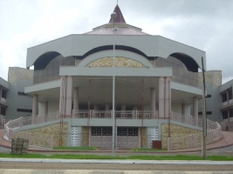

**Plate 1: Central Administration, UDS**

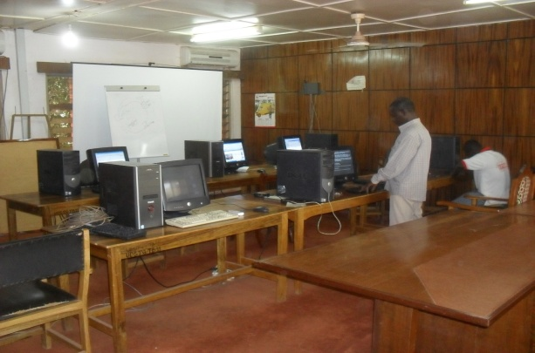

**Plate 2: Classroom, Graduate School, UDS**

Education in UDS blends modern with traditional practices found in its environs, for the benefit of students and communities.

## Third Trimester Field Practical Training Programme (TTFPT), Developed by the University for Development Studies

The main innovative feature of all the university programmes is Third Trimester Field Practical Training Programme (TTFPT), in which all students from year one to three participate, while final year students use this period for thesis preparation. Under this arrangement, students spend two trimesters in the classrooms, one of which will be dedicated to lectures exclusively, the third trimester, is spent in the field, within different communities of Ghana. Thus, students have opportunities to interact with rural people, gain insight into their problems and aspirations. Every academic year, over 12,500 students spend eight weeks in more than a thousand rural communities across Northern Ghana in this manner.

Through this highly interactive programme and other links of the university with the local community, many nationwide activities have been brought to the doorstep of the people in very remote parts of the country. Examples are National Health Insurance Awareness campaign, which made Ghana one of the first African countries to introduce citizens to the country-wide health insurance available to all, introduction of change and devaluation in national currency (from cedi to Ghana Cedi), National Identification Project, introduced to develop ID cards for all Ghanaians and foreign nationals living in the country and others. UDS students have actively supported these important national projects through information sharing, dissemination to the remote communities and holding local community fora to explain their importance and relevance at the local level.

The TTFPT is an iteration process using integrated approach, which offers students from each faculty/school of the university the opportunity to live and work together in selected communities. The programme covers three phases, engaging students from the first year through to the third year in a rural community. The work of each year builds on the previous year in a dynamic manner. Students are introduced to aspects of community studies during the first year, when they practice community entry and aspects of community diagnosis using participatory approaches. In the second year, emphasis is placed on techniques of needs assessment, culminating in the assessment of the problems and potentials of the community, using a variety of complementary techniques as well as suggested tentative/possible interventions.

The problems and potentials analyzed during the second year serve as the starting point of the activities for the third year, whereby students are tasked to propose pragmatic interventions to resolve observed problems. Students are expected to demonstrate the use of the identified possibilities for development on the field in their research proposals/community plans.

**Organisation and Funding of the Third Trimester**

First year students from the various faculties/schools undergo intensive orientation before being sent to the field. They are responsible for preparing schedule for work in the communities during this period, together with their lecturers, who serve in the supervision team. Work in the first year includes community entry process, qualitative and quantitative data collection, data analysis and synthesis, validation with community members, report writing and presentation, as well as final assessment of the report. Output of the first year work is a detailed profile of the chosen community with quantitative information available.

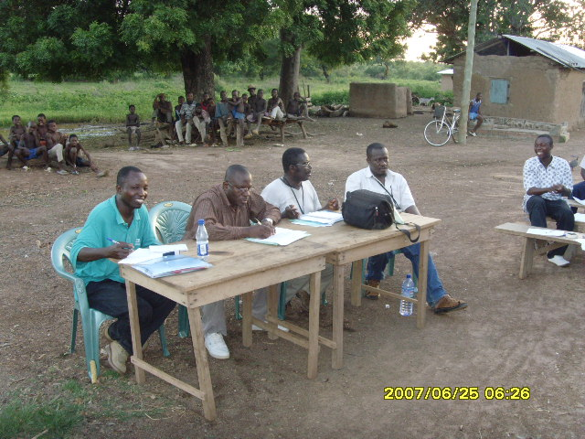

**Plate 3. Presentation of work in the community**

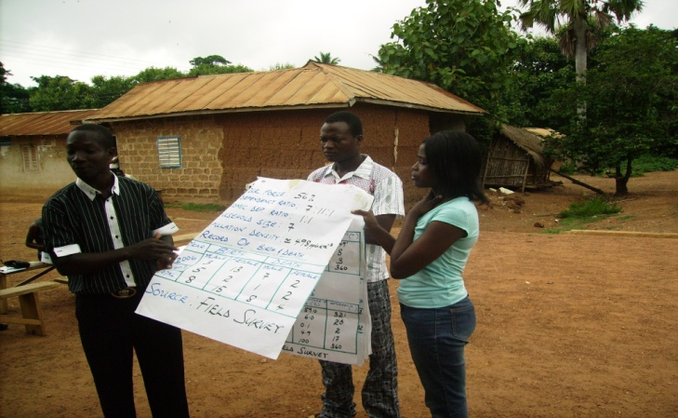

**Plate 4. Information obtained by students on the level field**

In year two**,** students apply methods and experiences acquired earlier to analyse the collected relevant data and identify developmental challenges and opportunities in the communities. They report directly to their study communities, where they organise community fora to present the results of the first year work and explain further tasks and engagements. In this case, students write a comprehensive report on the problems and potentials of the community being studied, with development problems outlined as well as suggested interventions.

The programme of the third year seeks to help students develop a favourable attitude to work in any type of environment. It also exposes students practically to the nature and dimensions of the problems plaguing rural communities. A programme of this nature requires careful planning and mobilisation of human and financial resources. Apart from engaging most of the teaching staff in careful monitoring and supervision of students while they stay in the community, UDS is also contributing about 58% (depending on the student numbers each academic year) of its total annual budget to TTFPT. Most of these funds are spent on transport, accommodation and other relevant expenditures for fieldwork.

Students also fund fieldwork. Out of the total student annual academic fees, the percentage paid towards TTFPT is only about 0.05%, but students pay for their food and other requirements, such as transport to and from the community they live in for the period of TTFPT, while accommodation is organised by the UDS.

## Community Benefits

Local benefits of the TTFTP are enormous. The programme involves almost all stakeholders in northern Ghana, from chiefs to district assemblies and other local-level structures. The University liaises with governmental, non-governmental agencies and organizations in the various communities and works with them and the people in the communities so that there is synergy and shared learning by all involved in the development efforts in the localities.

Through involvement in TTFTP, many rural communities in northern Ghana have obtained basic necessities, such as schools, drinking water source or road access. Their requests are brought to the attention of municipalities and included in the development plans of the government or relevant donor projects. Some NGOs (ex. Bright Horizons, a local organisation) also collaborated with UDS to bring rural children school books, sport shoes, and/or school uniforms.

## Concept of Doctoral Colleges

Another initiative currently developing at African universities is the establishment of doctoral colleges. Effective reforms in this respect started around 2005 which continued through 2013 in several key areas, resulting in significant developments (Mohamedbhai, 2014). For African universities, transforming the higher education sector is as important as expanding it. This involves, among other things, a shift in the quality, and a move away from single-discipline scholarship towards inter-disciplinary and trans-disciplinary collaboration (SARUA, 2012).

In Ghana, the aging nature of the faculty in most public universities and the lack of trained PhD scholars required to replace them, adds significantly to the needs for new fields of expertise required. Rather than sending individual doctoral candidates from each university to long and costly training abroad, Ghanaian public universities are developing a common platform to train them within the country, with the help of interested partners (such as the French Embassy in Ghana), who actively participate and assist this programme.

One example currently being worked on is teaching of mathematical sciences, an area lacking expertise in Ghanaian public and private universities. Mathematics studies are enjoying renewed interest among students in the country. Trained staff are urgently required at universities, especially to cover new fields such as data mining, networking, stochastic processes, and biometry.

Four public universities (University of Ghana, University of Cape Coast, Kwame Nkrumah University of Science and Technology and University for Development Studies) involved in the national programme met for the first time in 2011, to determine gaps and areas where expertise exists within the country, especially with respect to the identification of the possible supervisors for candidates. A programme of training was established and shared with interested foreign institutions. A course outline was then developed, making sure that all deficit areas needed for training were identified. Interested foreign institutions were invited to cover fields where expertise within the country is lacking.

This programme runs on a modular basis. Local universities provide funding for accommodation of candidates, fees for local teaching staff needed and other costs involved in the establishment and running of the modules. Tuition is carried out at central location, suitable for all Ghanaian partners. Foreign partners voluntarily contribute time and expertise, mostly during long vacation period, while host institutions in Ghana usually cover foreign, alongside local travel and accommodation expenses and some reimbursement for time spent in teaching. Identification of candidates attached to each of the supervisors is done during the training module in Ghana, but supervision may continue online, with follow–up visits and probably short stays of candidates in the foreign institutions, to obtain specific training not available within the country.

The benefit for local institutions is obvious: instead of paying for long and costly PhD study abroad for one candidate, always with attending the possibility that she/he may not return, there is training of four to five candidates for each university at the same period within the country, with an opportunity given them to still participate in the academic life of their school/faculty, while pursuing the PhD programme. The first beneficiaries of this programme are yet to complete studies, with expected graduation dates set tentatively for 2014/2015. Similar to the programme of mathematical sciences, there are moves to develop similar models for deficit areas in the medical sciences, climate change studies, agricultural engineering, and many others, with partners from Denmark, Germany and other interested countries.

# **Conclusion**

Public universities in Ghana are jointly developing new educational models driven by the needs of the society, to serve institutions for higher learning and reduce drain of young professionals from the country. The fact that the majority of the graduates from UDS, for example, are currently working in rural communities is a testimony to the impact of this innovative and sustainable training approach. Through field practical training programme, critical questions of equity and access are also addressed, separating them from the traditional approaches. If the concept is institutionalized from the very onset in the training of young scientists and professionals, it serves in ensuring changes in their perceptions and attitudes with regards to development among the future generation.

The doctoral colleges’ concept works towards up-scaling and training of critical staff within the country, in disciplines where their expertise is most needed. This concept reduces the cost of doctoral studies per candidate, making it possible to train a large number of critically needed staff within a given time and available funding resources. These innovative approaches are both built on the concepts of education for sustainable development (GUNi, IAU and AAU, 2011), effectively manage resources, and most importantly, create models of tertiary education that offer beneficiaries increased capacity to solve local problems.

# **References**

African Association of Universities (AAU) (2009). Abuja Declaration on Sustainable Development in Africa: The Role of Higher Education. 12th General Conference of AAU, co-hosted by the University of Ilorin and the University of Abuja, Abuja, Nigeria, 4–9 May.

Azcona, G., R. Chute, F. Dib, L. Dookhony, H. Klein, P. Loyacano, D.D. Randazzo and V. Reilly (2008). *Harvesting the Future: The Case for Tertiary Education in Sub-Saharan Africa*, The Maxwell School of Syracuse University, Syracuse, United States of America.

Black, R., K. Russell and R. Tiemoko (2003). Migration, Return and Small Enterprise Development in Ghana: a route out of poverty? Sussex Migration Working Paper no 9, Sussex Migration Research Centre, Brighton, United Kingdom.

Castells, M. (2000). *The Rise of the Network Society: The Information Age: Economy, Society and Culture*. Blackwell, Oxford, United Kingdom.

Doh, P.S. (2012). *The Responses of the Higher Education Sector in the Poverty Reduction Strategies in Africa. The Case of Cameroon*. PhD Thesis, Tampere University, Tampere, Finland p. 338.

Gibbons, M. (1994).*The New Production of Knowledge: The Dynamics of Science and Research in Contemporary Societies*. SAGE, London, United Kingdom.

Global University Network for Innovation (GUNi), International Association of Universities (IAU) and Association of African Universities (AAU) (2011). *The Promotion of Sustainable Development by Higher Education Institutions in Sub-Saharan Africa. A survey Report.*

Hazelkorn, E. (2005). *Developing Research in New Institutions*, OECD, Paris, France.

Kaburise, J.B.K. (2003). New variations on the African Development University: The UDS Experience with developing an Alternative Approach to Tertiary Education. A case study prepared for a Regional Training Conference on Improving Tertiary Education in Sub-Saharan Africa: Things That Work! Accra, September 23-25.

International Association of Universities (IAU) (2011). Changing Nature of Doctoral Studies in sub-Saharan Africa. Challenges and Policy Development Opportunities at six universities in Sub-Saharan Africa. *E-Bulletin*, Vol. 8, No 7, September 2011.

Mamdani, M. (2002). African Universities in their Local and Global Contexts. Paper presented at Partnership for Higher Education Workshop. Abuja, Nigeria, 18 March.(in: Manuh, T., Gariba, S.,& J.Budu (2007).*Change and Transformation in Ghana’s Publicly Funded Universities*, Partnership for Higher Education in Africa, Woeli Publishing Services, Accra, Ghana.

Manuh, T., Gariba, S., & J. Budu (2007). *Change and Transformation in Ghana’s Publicly Funded Universities*, Partnership for Higher Education in Africa, Woeli Publishing Services, Accra, Ghana.

Mohamedbhai, G. (2014). Major higher education reforms to continue in 2014, *University World News*, Issue 302.

Mutume, G. (2003). Reversing Africa's 'brain drain'. New initiatives tap skills of African expatriates, *Africa Recovery*, Vol.17, No 2.

National Accreditation Board (2013).Official website, Tertiary Institutions in Ghana Accessed 22 December 2013.

Network of African Science Academies (NASAC) (2009). *Brain drain in Africa*. Joint Statement by the Network of African Science Academies. Brain

Powel, W.W. and K. Snellman (2004). The Knowledge Economy, *Annual Review of Sociology* 30, 199–220.

Ramphele, M. (2004). The university as an actor in development: new perspectives and demands. *Journal of Higher Education in Africa* 2 (1), 15-33.

SARUA (2012). Doctoral Education-Renewing the Academy, SARUA Leadership Dialogue Series Vol. 4, No 1.

World Bank (2002). Constructing Knowledge Societies: New Challenges for Tertiary Education, Washington D.C., United States of America.

UISFact sheet (2010). Trends in tertiary education in Sub-saharan Africa. UnESCO Institute for Statistics, No 10.

Varghese, N.V. (2013). Government and Governance Reforms in Higher Education in Africa. *International Higher Education* 73, 13-14.