Prevalence of Skin Infections and Hygiene Practices among Pupils in selected Public Primary Schools in Ibadan, Nigeria

¹MORAKINYO O.M., ²G.R.E.E. ANA & ³ E.O. OLORUNTOBA

¹Department of Environmental Health Sciences,Faculty of Public Health, College of Medicine, University of Ibadan.
Email: wahlemirax@gmail.com
²Department of Environmental Health Sciences, Faculty of Public Health, College of Medicine, University of Ibadan, Nigeria.
Email: anagrow@yahoo.com
³Department of Environmental Health Sciences, Faculty of Public Health, College of Medicine, University of Ibadan, Nigeria.
Email: li_zzyy@yahoo.com

Abstract

Skin diseases are among the common childhood problems of public health importance in Nigeria. Poor personal hygiene practices especially among children are believed to be contributory to its prevalence. This study assessed the prevalence of skin infections and practices in relation to hygiene among public primary school children in Ibadan, Nigeria. A descriptive cross-sectional design was adopted. A simple random sampling method was used in selecting five public primary schools from the seventy-six schools in Ibadan North Local Government Area, Nigeria. Physical examination of 1,109 pupils in primaries three to six by Physicians in five schools was used to assess the presence of skin infections. Microscopic examination of scalp scrapings from pupils diagnosed with skin infection was done so as to identify the causative organisms. Semi-structured interviewer administered questionnaire was used in obtaining information on socio-demographic information, personal hygiene and treatment practices. Data were analysed using descriptive statistics. The mean age of the infected children was 11.0 (±1.93) years. Clinically diagnosed cases of skin infections were found in 260 (23.4%) pupils, with more males (77.7%) infected than females (22.3%). Types of skin infections diagnosed were Tineacapitis (93.8%); Pityriasisversicolor (3.1%) and Skin furuncles (0.4%) while (2.7%) had multiple infections. The identified causative dermatophytes from the scalp scrapings were Trichophytonmentagrophytes (72.0%) and Trichophytontonsurans (28.0%). Proportion of infections among pupils were, primary three (33.5%); primary four (29.6%); primary five (19.2%) and (17.7%) for primary six. Pupils whose parents’ do not live together accounted for 65.0% of the infected pupils compared to 35.0% whose parents stay together. About 73.4% reported they had at least one person with skin infection in their homes. About 77.0% of the cases were found in children living in crowded conditions of more than three persons per standard room; sharing of items (comb, bed, towel) was reported in 93.1% of cases. Of the 120 positive cases, 54.2% reported they take bathing their bath once daily; the remaining 45.8% bathe twice daily. Practices in the treatment of infections like the use of herbal soap (31.5%), brake oil (4.2%), Baby oil (3.9%), chicken’s egg (2.7%) were reported by respondents. Poor personal hygiene and housing conditions are contributing factors to skin infections in the study area. Early introduction of health education in schools would encourage pupils to imbibe culture of personal cleanliness.

Key words: Skin infections, school pupils, hygiene practices

Introduction

Skin infection is a broad term given to various infections of the skin caused by the presence and colonisation of microorganisms (Bhumbra and McCullough, 2003; Sladden and Johnston, 2004). Invasion and multiplication of pathogenic microscopic organisms such as bacteria, viruses and fungi, in parts of the body or tissue of a host, may produce tissue injury and progress to overt disease through a variety of cellular or toxic mechanisms. The infecting organism or pathogen interferes with the normal functioning of the skin and perhaps the survival of the host organism thus leading to infection. Infectious agents (pathogens) like bacteria and fungi, frequently cause or aggravate skin infections (WHO, 2005).

Fungal infections that affect the skin and adjacent structures are common in all environments. They include infections such as ringworm or dermatophytosis; superficial candidiosis and infections caused by lipophilic yeasts and Malasseziaspecies; and some other common causes of foot infection such as Scytalidium. Superficial fungal infections in children are usually caused by yeasts (e.g., Candida, Malassezia) or dermatophytes (e.g., Trichophyton,Microsporium, and Epidermophyton). They infect and survive on dead keratin and persist in the stratum corneum. Rarely do they penetrate below the surface of the epidermis. The skin responds to this superficial infection by increased proliferation, which leads to scaling and epidermal thickening. It is estimated that 10% to 20% of the world's population is infected by a dermatophyte (Hay and Moore, 1998).

Skin problems are generally among the most common diseases seen in primary care settings in tropical areas and in some regions where transmissible diseases such as tineaimbricata or onchocerciasis are endemic (Mahéet al., 1995). Skin diseases form a substantial part (10-24%) of the total childhood morbidity encountered in general practice (Julian, 1999).

The World Health Organization’s 2001 report (Matherset al., 2001) on the global burden of disease indicated that skin diseases accounted for about 20,000 deaths in Sub-Saharan Africa in 2001. This burden was comparable to mortality attributed to meningitis, hepatitis B, obstructed labour, and rheumatic heart disease in the same region. Skin infections and infestations affect 49.2 - 80.4% of African primary school children (Ogunbiyiet al., 2005).

Dermatophytosis inflicts a lot of psychosocial trauma due to attached social stigma, ulceration, and sometimes irritation which hampers pupil’s concentration in class as well as representing a potential source of secondary bacterial infection. It is not generally appreciated how disabling a skin disease can be since an apparent trivial rash to the observer may be a source of intense discomfort and stigma (Bibekaet al., 2006).

Three main factors have been generally incriminated as reasons for high prevalence of common skin diseases in developing areas especially among primary school pupils. These are a low level of hygiene, including difficulties in access to water; climatic factors; and overcrowding (Figueroaet al., 1996).

Owing to the low level of priority given to skin infections by health decision-makers, there is a near total ignorance about common skin disorders at the different levels of the health system in less developed countries. Hence, this study assessed the prevalence of skin infections and practices in relation to hygiene among public primary school children in Ibadan, Nigeria.

Methodology

The study was carried out in Ibadan, located in south-western Nigeria; 120 km inland from Lagos, a transit point between the coastal region and the areas to the North. It is located at an altitude ranging from 152 – 213m with isolated ridges and peaks rising to 247m.

The study was descriptive cross-sectional in design. Pupils between classes three and six from five randomly selected public primary schools were recruited into the study. Diagnoses of skin infections and infestations for each pupil were made following the physical examination by a Physician. The skin, scalp, eyebrows, and eyelashes of each child were carefully examined for characteristic features of Tineacapitis, Pityriasisversicolor and other superficial skin infections.

A semi-structured, interviewer administered questionnaire was administered on pupils diagnosed of skin infection to elicit information on socio-demographic information, personal hygiene and treatment practices. Verbal and written consent was received from parents of each respondent through the Parents and Teachers Association (PTA). The study was conducted with the understanding and the consent of the participants. Confidentiality of information was maintained throughout the study.

Data was cleaned up and a coding guide developed to facilitate data entry. It was thereafter imputed into a computer for analysis using Statistical Package for Social Sciences (SPSS) version 16. Descriptive Statistics of mean, standard deviation and percentages was used to analyse the data.

Results and Discussion

A total of 1,109 primary school students were physically examined for skin infection. Mean age of the infected children was 11.0 (±1.93) years. Clinically diagnosed cases of skin infections were found in 260 (23.4%) pupils, with more males (77.7%) infected than females (22.3%). A majority of the pupils diagnosed for skin infections were in the 10 –12 years age group; the proportion of infections among pupils reduces from primary three (33.5%) to primary six (17.7%) as shown in Table 1.

Table 1: Socio-Demographic Characteristics of Pupils

Variable | Frequency (N = 260) | Percentage (%)
Sex
Male | 202 | 77.7
Female | 58 | 22.3
Age (in years)
7 – 9 | 53 | 20.4
10 – 12 | 157 | 60.4
≥ 13 | 50 | 19.2
Class of pupil
Primary three | 87 | 33.5
Primary four | 77 | 29.6
Primary five | 50 | 19.2
Primary six | 46 | 17.7
Marital status of parent
Married (staying together) | 91 | 35
Married (living separately) | 169 | 65

Among the 260 respondents clinically diagnosed for skin infections, 93.8% had Tineacapitis; 3.1% had Pityriasisversicolor; 0.4% had Skin furuncles while 2.7% had multiple infections (Figure 1).

Figure 1: Diagnosed Skin Infections among Pupils

Figure 2 and 3 show some diagnosed cases of Tineacapitisduring the physical examination of pupils for infections. Among the clinically diagnosed cases, 76.2% do not have personal clipper as compared to 23.8% who has.

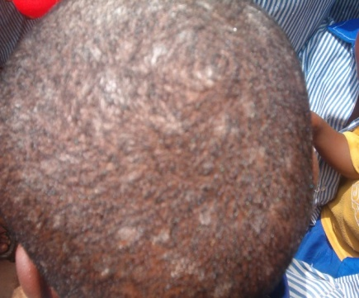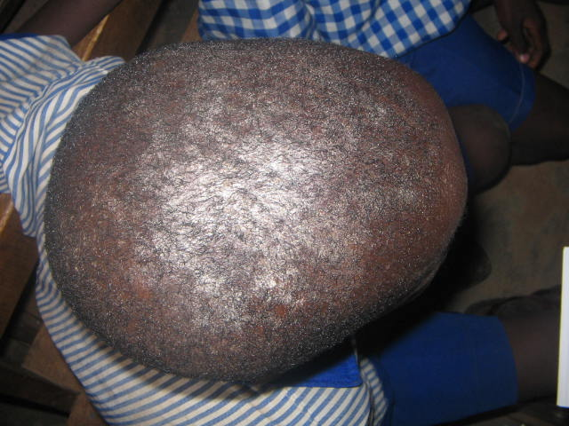

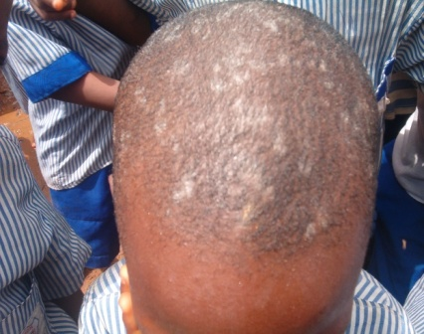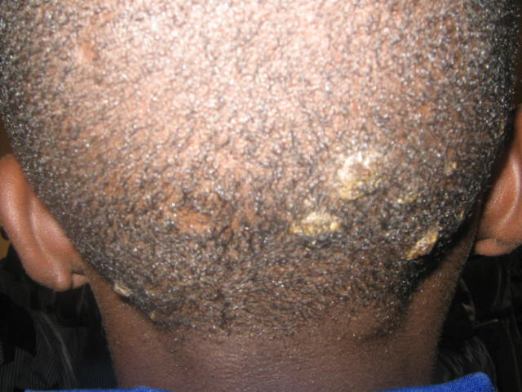

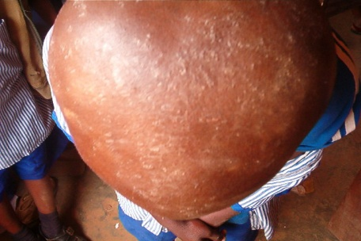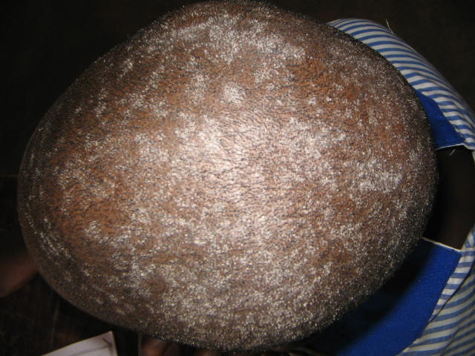
Figure 2: Diagnosed cases of scalp infection

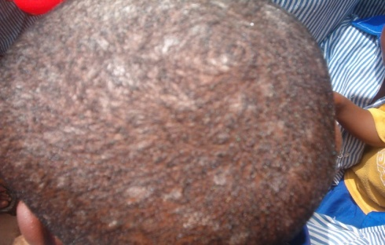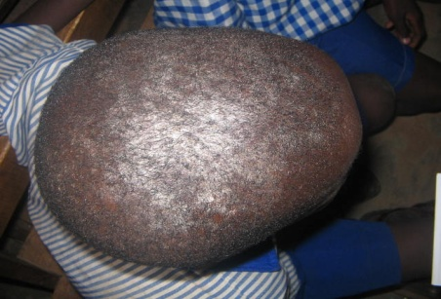

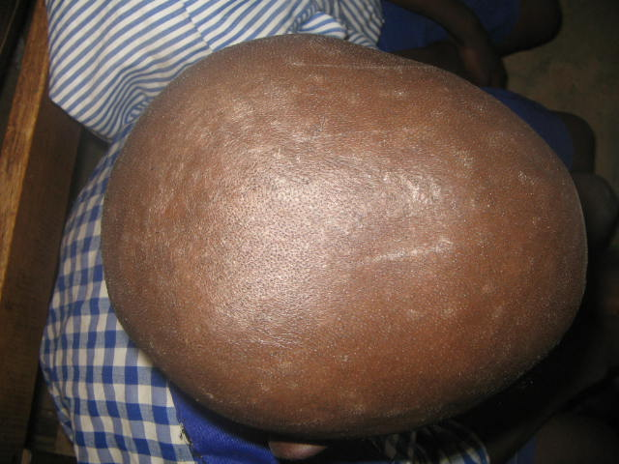

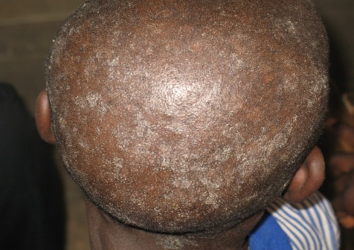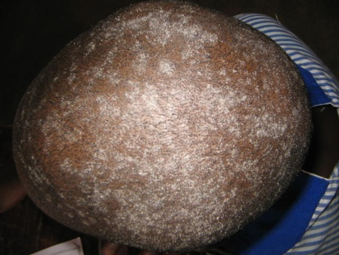
Figure 3: Diagnosed Cases of Scalp Infection

Of the 120 positive cases, 54.2% reported they take their bath once daily; the remaining 45.8% took theirs twice daily (Table 2). Sharing of items such as comb, bed, towel and hat were reported in (93.1%) of the pupils. Most of the positive cases (73.5%) were found among children living in crowded conditions of more than three persons per room; the remaining 26.5% lived in less crowded rooms.

Table 2: Hygiene Related Practices among Pupils

Variable | Frequency | Percentage
Possesses personal clipper  Yes  No | 62  198 | 23.8  76.2
Frequency of bathing  Once  Twice | 141  119 | 54.2  45.8
Sharing of items (bed, comb, towel)  Yes  No | 242  18 | 93.1  6.9

Perceived sources of infection as reported by pupils were documented in Table 3. About 18% of pupils believed they contacted it from barber’s clippers; 15.8% from friends; 6.1% reported it is from irregular bath; 5.0% reported playing in sand while majority (55.0%) did not know the source of infection.

Table 3: Perceived Sources of Infection among Pupils

Source of infection | Frequency | Percentage
Do not know | 143 | 55.0
Barber’s clipper | 47 | 18.1
Friends in school | 41 | 15.8
Irregular bath | 16 | 6.1
Playing in sand | 13 | 5.0

Table 4 presents treatment practices adopted by pupils. About 32% had used herbal soap; 11.9 used medicated soap; 6.9% used drugs prescribed by a physician while 6.5% used chicken’s egg. Other treatment methods adopted include salt water (5.8%), brake oil (4.2%) and lime (3.9%).

Table 4: Treatment Practices

Source of infection | Frequency | Percentage
Herbal soap | 82 | 31.5
None | 76 | 29.2
Medicated soap | 31 | 11.9
Doctor’s prescribed drugs | 18 | 6.9
Chicken’s egg | 17 | 6.5
Salt water | 15 | 5.8
Brake oil | 11 | 4.2
Lime | 10 | 3.9

The results of this investigation indicate that superficial fungal infections, especially caused by dermatophytes, represent a relatively common problem among children of school age in Ibadan, Nigeria. The examination of 1,109 primary school children revealed a prevalence rate of 23.4%. This prevalence is comparable to the 28.2% reported in Taiwan (Wu, et al., 1996). However, it is low when compared with prevalence of skin infection and infestation rate of 40.4% among Nigerian primary school pupils in a study carried out by Olusola et al. 2006 and the findings of Ogunbiyiet al., 2005 in their school survey of skin disorders in school children in Ibadan in which a rate of 35.2% was observed.

The prevalence of skin infection in this study was significantly higher in males than females. This was consistent with findings from previous studies conducted among primary school children in Nablus, Palestine (Ali-Shtayehet al., 1990), Amsterdam, Holland (Timenet al., 1999), Tikrit, Iraq (Fathi and Al-Samarai, 2000) and Ijesa-land, Nigeria (Olusolaet al., 2006).The higher prevalence of Tineacapitis among the boys in this study, may be attributed to the very short hair styles kept by the males which encourages easy implantation of spores, their habit of frequent visit to local barbers where the instruments are rarely disinfected, exchange of caps and rubbing of the hair during play as well as lack of consistent hygienic attention to the scalp.

The prevalence of Tineacapitis 22.2% observed is relatively high when compared with other surveys of Omar, 2000 in Alexandria (7.4%), those ofFathi and Al-Samarai, 2000 among Iraq children (2.7%) as well as those of Ogunbiyiet al., 2005 among school children in Ibadan, Nigeria (15.2%). Decrease in infection rate noticed across the classes from primary three to six may be attributed to increase in knowledge about personal hygiene.
However, it is generally reported that Pityriasisversicolor is relatively uncommon in children (Gupta, 2002), the prevalence of the infection observed in this study (0.7%) was lower when compared to what was recorded among children in Bamako, Mali (1.6%) (Faye et al., 2005), Calabar, Nigeria (3.7%) (Akpataet al., 1990) and Tapei, Taiwan (4.4%) (Wu, 2000).Pityriasisversicolor is known to be predisposed by excessive sweat increase in humidity, temperature and carbon dioxide tension (Gupta et al., 2002; Burkhart, 2005).

The habit of bathing once a day despite the profuse sweatingduring play at school was common among respondents. Earlier studies show that unclean skin favours the development of pathogenic organisms (Shrumet al., 1994).The habit of respondents not sharing hair clippers and kits and the frequent visit to local barbers where instruments are rarely disinfected are also important factors in infection transmission.

It was noticed that most of the respondents lived in rooms that are crowded (more than three persons per room). In accordance with characteristics peculiar to crowded rooms, movement would be restricted, privacy secluded, hygiene impossible, while rest and sleep difficult, to an extent that these may enhance the direct transmission of infection. [23] Anosikeet al., 2005 had argued that poor infrastructures (houses and classrooms) are contributing factors to the high prevalence of dermatophytes amongst school children in Northern Ebonyi, Nigeria. The need for proper treatment of infected persons in pupils’ homes should be explored so as to discourage re-infection.

With the majority of the respondents, 96.9%, aware of their infections and with 44.6% saying they have lived with infection for more than a year. It can be concluded that the pupils’ health seeking behaviour is poor. This is consistent with a study conducted in rural Mali where the health seeking behaviour for the different skin disorders recorded during a prevalence study in children was determined. 40% of tineacapitis cases justified a visit to a health center (Maheet al., 1995). Programmes that would promote better utilization of health facilities and appropriate treatment options among parents should be encouraged. School teachers should be taught how to recognize infection and infestation while school health inspections should be made compulsory.

Some of the respondents mentioned use of brake oil, detergent, chicken’s egg, grease, lime etc. Unsafe practices in the treatment of infections like the use of alcohol, kerosene, oil and insecticides have also been observed by Magee et al., 1996. These were found to be the most popular remedies adopted by those infested. However, one is likely to incompletely treat skin infections by these methods; one needs to educate the children and adults on the appropriate treatment by more effective means since most respondents reported treatment failure.

Conclusion
This present work has revealed the existence of skin infections as well as poor personal hygiene practices among the study population. Environmental and Health education programmes should be instituted to raise awareness about skin infections, its causes and its prevention. These will also serve as a means of educating people on different health risk behaviours. There is also the need for educating the children and adults on the complete treatment. Early introduction of health education in schools would encourage school pupils to imbibe the culture of both personal and environmental cleanliness.

Acknowledgement

The authors express gratitude to the management and staff as well as the Parents Teachers Association of the schools for their assistance and cooperation in collecting data for the study.

References

Akpata, L.E., H.C. Gugnani and S.J. Utsalo (1990). Pityriasisversicolor in school children in Cross River State of Nigeria.Mycoses33: 549-51.
Ali-Shtayeh, M.S., H.M. Arda and S.I. Abu-Ghdeib (1990). Epidemiological study of tineacapitis in school children in the Nablus area (West Bank).Mycoses41: 243-248.
Anosike, J.C, I.R. Keke, J.C. Uwaezuoke, J.C. Anozie, C.E. Obiukwu, B.E.B. Nwoke, and O.U. Amajuoyi (2005). Prevalence and distribution of ringworm infections in Primary School Children in parts of Eastern, Nigeria.J. Appl. Sci. Environ. Mgt9.3: 21- 25.
Bhumbra, N.A. and S.G. McCullough (2003). Skin and subcutaneous infections. Prim Care 30(1):1–24.
Bibeka, N.J., K.G. Vijay, S. Agrawal et al. (2006). Tineacapitisin Eastern Nepal.Int. J. Dermatol. 45:100-103.
Burkhart, C.G (2006). Tineaversicolor. [Updated 2005 May 4; accessed on 2006 Feb 25]. Available from: [www.emedicine.com/derm/ topic423].
Fathi, H.I. and A.G. Al-Samarai (2000). Prevalence of tineacapitis among school children in Iraq.Eastern Mediterranean Health Journal6:128-37.
Faye, O., H.T. N'Diaye, S. Keita, A.K Traore, R.J. Hay and A. Mahe (2005). High prevalence of non-leprotic hypochromic patches among children in a rural area of Mali, West Africa. Leprosy Review76: 144-6.
Figueroa, J.I., L.C. Fuller, A. Abraha and R.J. Hay (1996). The Prevalence of Skin Disease among School children in Rural Ethiopia: A Preliminary Assessment of Dermatologic Needs. Pediatric Dermatology 13: 378–81.
Gupta, A.K., R. Bluhm and R. Summerbell (2002). Pityriasisversicolor.J EurAcadDermatolVenereol16: 19-33.
Hay, R.J. and M. Moore (1998). Mycology.In: Rook A, Wilkinson DS and Ebling FJ. Textbook of dermatology, 6th ed. Oxford: Blackwell Scientific pg. 1277-1376.
Julian, C.G. (1999). Dermatology in general practice. Br J.Dermatol; 141: 518, 520.
Magee, J. (1996). Unsafe practices in the treatment of pediculosiscapitis. J. Sch. Nurs. 12:17-20.
Mahé, A., A. Prual, M. Konaté and P. Bobin (1995). Skin diseases of children in Mali: a public health problem. Trans R Soc Trop Med Hyg89: 467- 470.
Mathers, C.D., A.D. Lopez, and C.J.L. Murray (2001). The Burden of Disease and Mortality by Condition: Data, Methods, and Results for 2001.” In Global Burden of Disease and Risk Factors, eds. A. D. Lopez, C. D. Mathers, M. Ezzati, D. T. Jamison, and C. J. L. Murray. New York: Oxford University Press.
Ogunbiyi, A.O., E. Owoajemand A.A. Ndahi (2005). Prevalence of Skin Disorders in School Children in Ibadan, Nigeria.Pediatric Dermatology 2005; 22. 1: 6-10.
Olusola, A.O., J.A.O. Okeniyi, T.A. Ogunlesi, O. Onayemi, G.A. Oyedeji and O.A. Oyelami (2006). Parental Factors Influencing the Prevalence of Skin Infections and Infestations among Nigerian Primary School Pupils.The Internet Journal of Dermatology 3.
Omar, A.A. (2000). Ringworm of the scalp in primary school children in Alexandria: infection and carriage. Eastern Mediterranean Health Journal6.5: 961-967.
Shrum, J.P., L.E. Millikan and O. Bataineh (1994). Superficial fungal infections in the tropics. Dermatology Clinic12: 687-93.
Sladden, M.J. and G.A. Johnston (2004). Common skin infections in chil dren. BMJ 329(7457):95–9.
Timen, A.,L. Bovee, A. Leentvaar-Kuijpers, P.G. Peerbooms and R.A. Coutinho (1999). [Tineacapitis in primary school age children in southeastern Amsterdam: primarily due to Trichophytontonsurans] [Article in Dutch].Ned TijdschrGeneeskd143: 24-27.
WHO (2005). Epidemiology and Management of Common skin diseases in Children in Developing Countries, Department of Child and Adolescent Health and Development.
Wu, Y.H., H.Y. Su and Y.J Hseih (2000). Survey of infectious skin diseases and skin infestations among primary school students of Taitung country, Eastern Taiwan. J Formos Med Assoc. 99: 128-34.

